Lenin on Demagogues
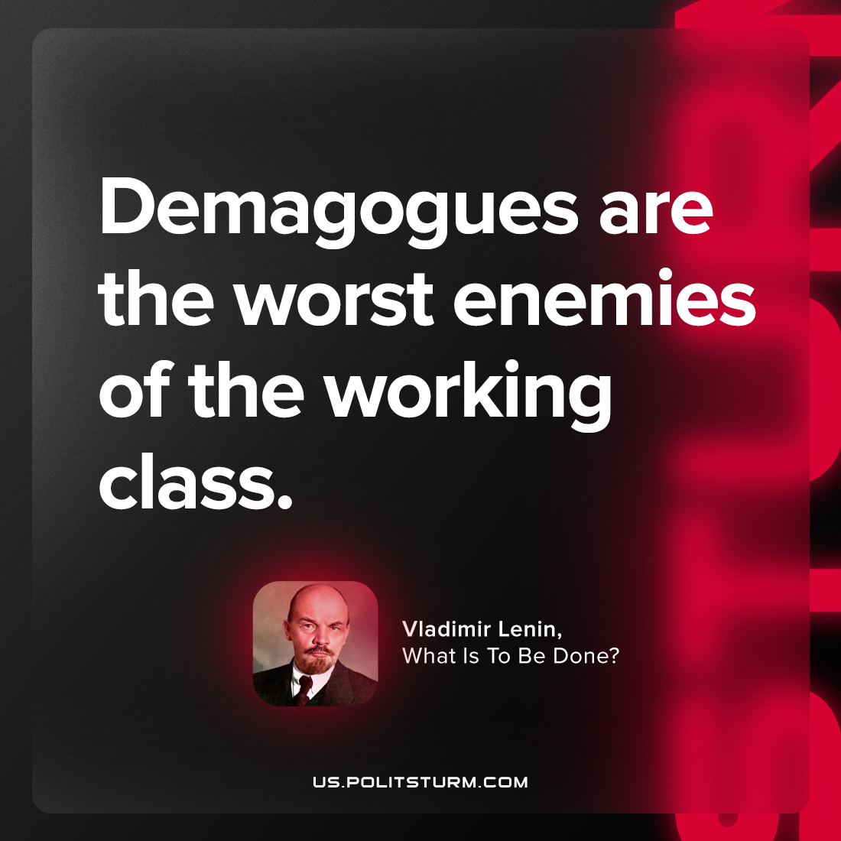

Original article
2023-06-06

"Demagogues are the worst enemies of the working class."
Vladimir Lenin, What Is To Be Done?

Original article

