Lenin on Criminal Wars
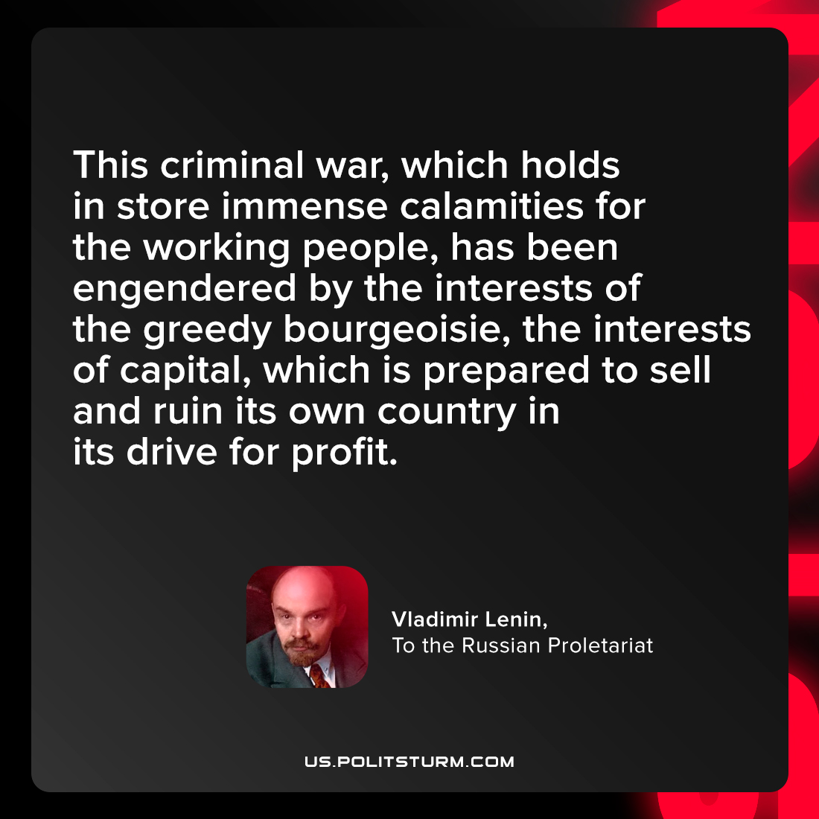

Original article
2022-03-01

This criminal war, which holds in store immense calamities for the working people, has been engendered by the interests of the greedy bourgeoisie, the interests of capital, which is prepared to sell and ruin its own country in its drive for profit.

Vladimir Lenin, “To the Russian Proletariat”

Original article

