Lenin on Converting the Fighting Proletariat into a Nationalist Movement Strengthening the Capitalist
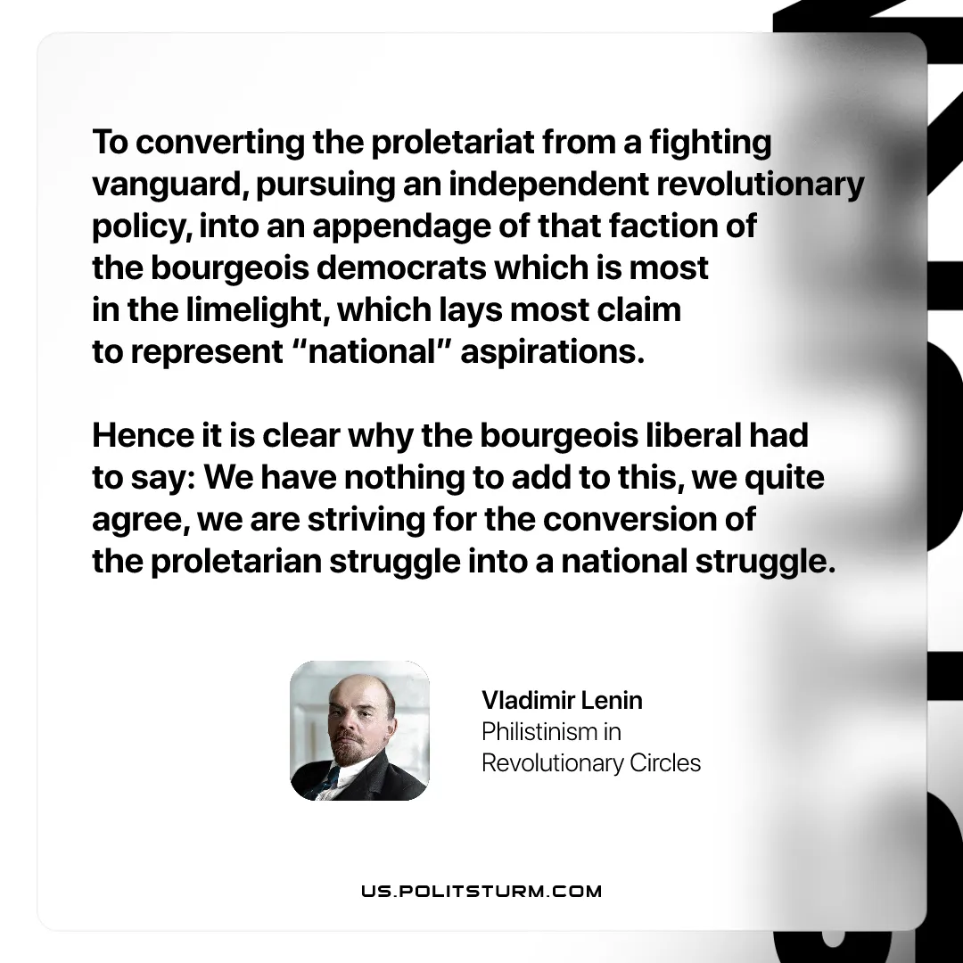

Original article
2026-01-25

“To converting the proletariat from a fighting vanguard, pursuing an independent revolutionary policy, into an appendage of that faction of the bourgeois democrats which is most in the limelight, which lays most claim to represent “national” aspirations. Hence it is clear why the bourgeois liberal had to say: We have nothing to add to this, we quite agree, we are striving for the conversion of the proletarian struggle into a national struggle.
Vladimir Lenin, Philistinism in Revolutionary Circles

Original article

