Lenin on Consoling the Slave
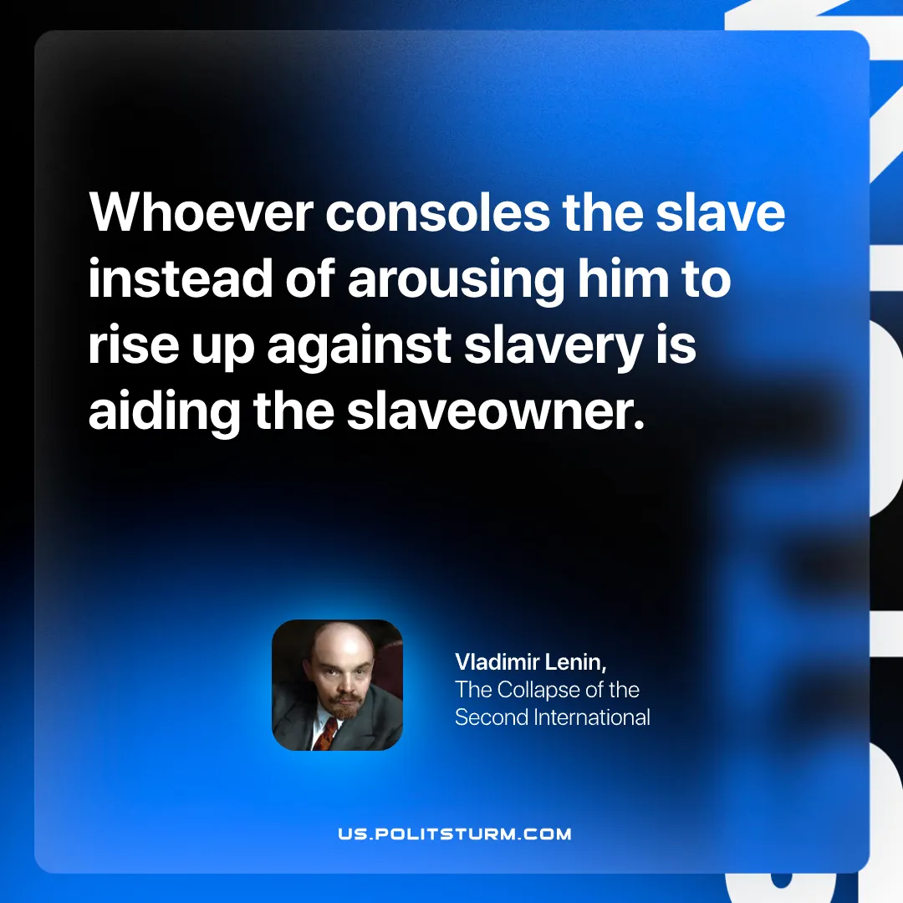

Original article
2026-09-20

Whoever consoles the slave instead of arousing him to rise up against slavery is aiding the slaveowner.
Vladimir Lenin, The Collapse of the Second International

Original article

