Lenin on Conscious Class Struggle
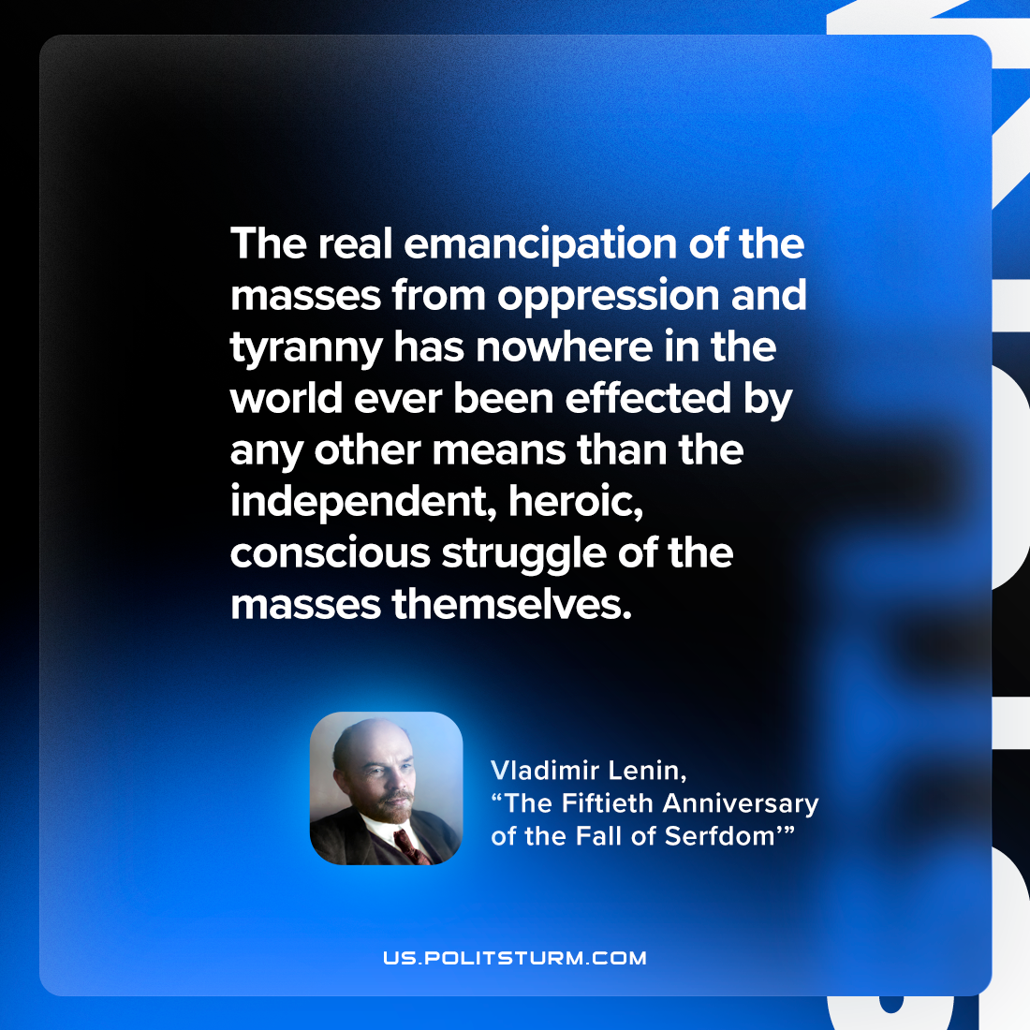

Original article
2023-03-18

"The real emancipation of the masses from oppression and tyranny has nowhere in the world ever been effected by any other means than the independent, heroic, conscious struggle of the masses themselves."
Vladimir Lenin, “The Fiftieth Anniversary of the Fall of Serfdom”

Original article

