Lenin on Concentration of Capital
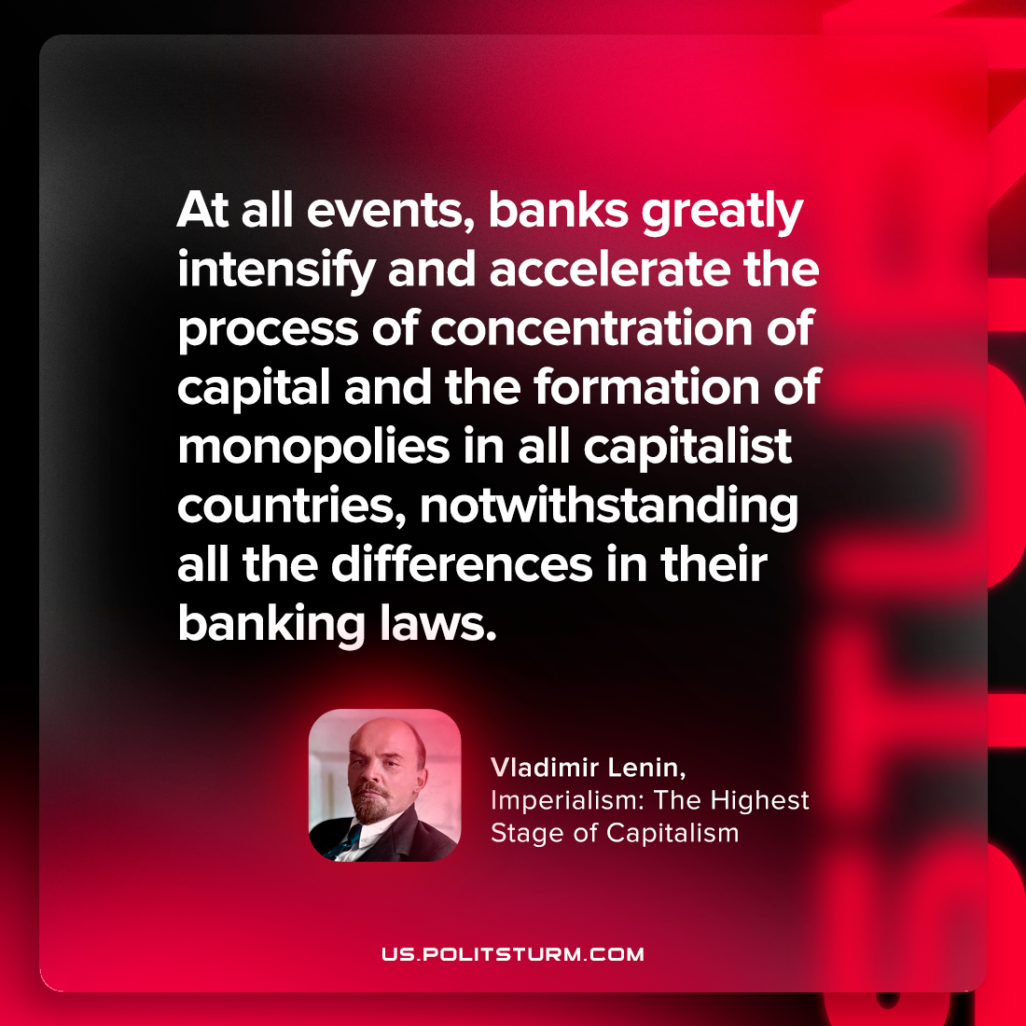

Original article
2023-09-09

"At all events, banks greatly intensify and accelerate the process of concentration of capital and the formation of monopolies in all capitalist countries, notwithstanding all the differences in their banking laws."
Vladimir Lenin, Imperialism: The Highest Stage of Capitalism

Original article

