Lenin on Compromises to the Bourgeoisie
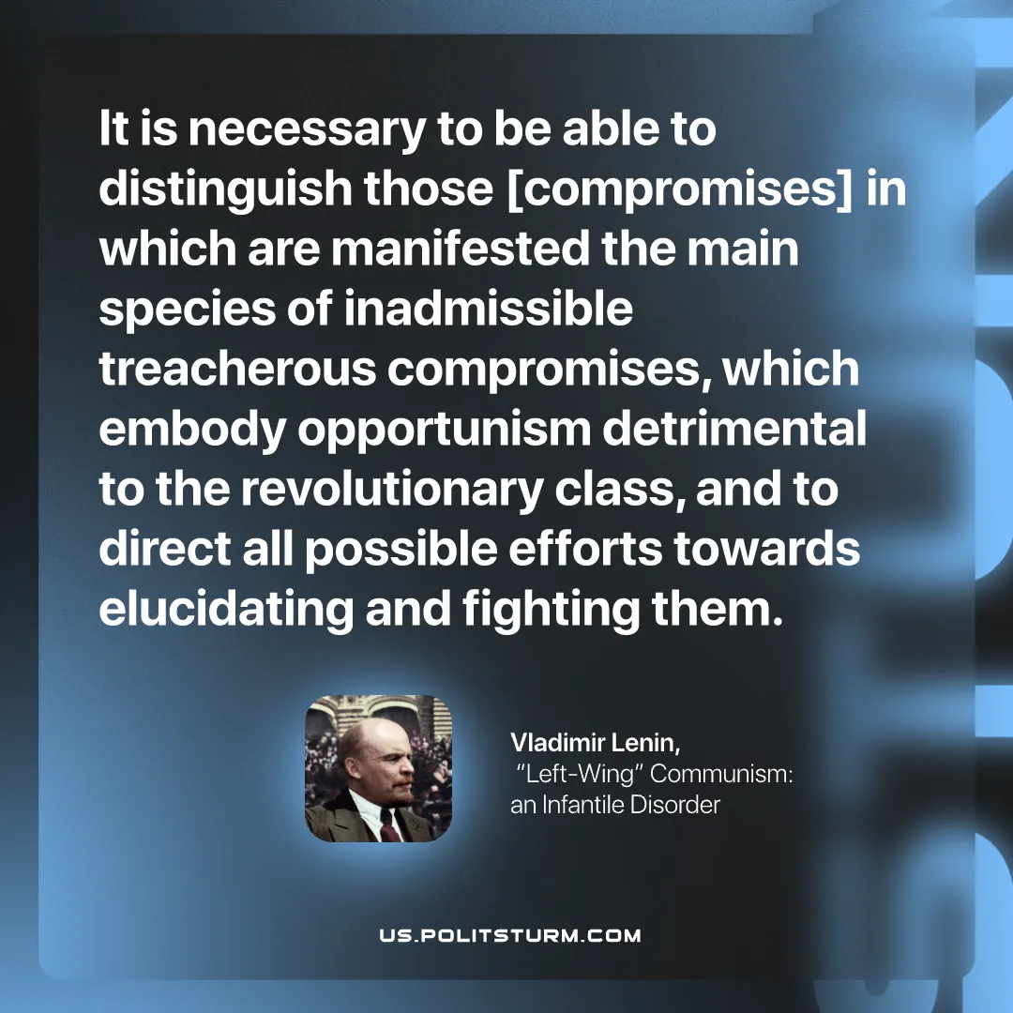

Original article
2026-06-07

It is necessary to be able to distinguish those [compromises] in which are manifested the main species of inadmissible treacherous compromises, which embody opportunism detrimental to the revolutionary class, and to direct all possible efforts towards elucidating and fighting them.
Vladimir Lenin, “Left‑Wing” Communism: an Infantile Disorder

Original article

