Lenin on Complacency and Arrogance
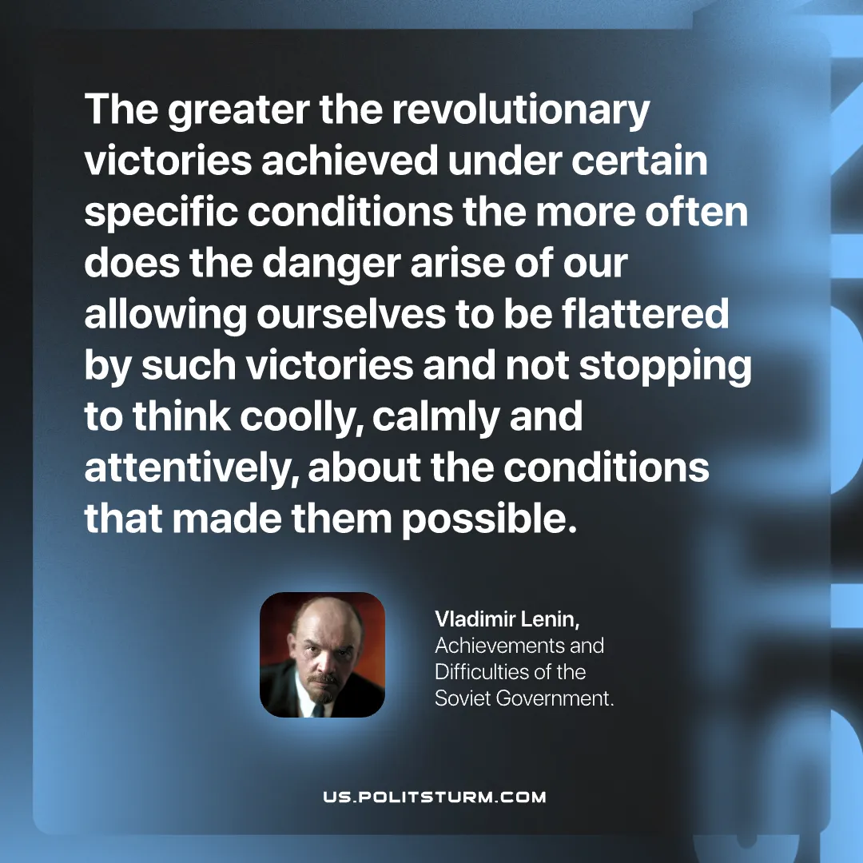

Original article
2026-05-28

The greater the revolutionary victories achieved under certain specific conditions the more often does the danger arise of our allowing ourselves to be flattered by such victories and not stopping to think coolly, calmly and attentively, about the conditions that made them possible.
Vladimir Lenin, Achievements and Difficulties of the Soviet Government.

Original article

