Lenin on Communists
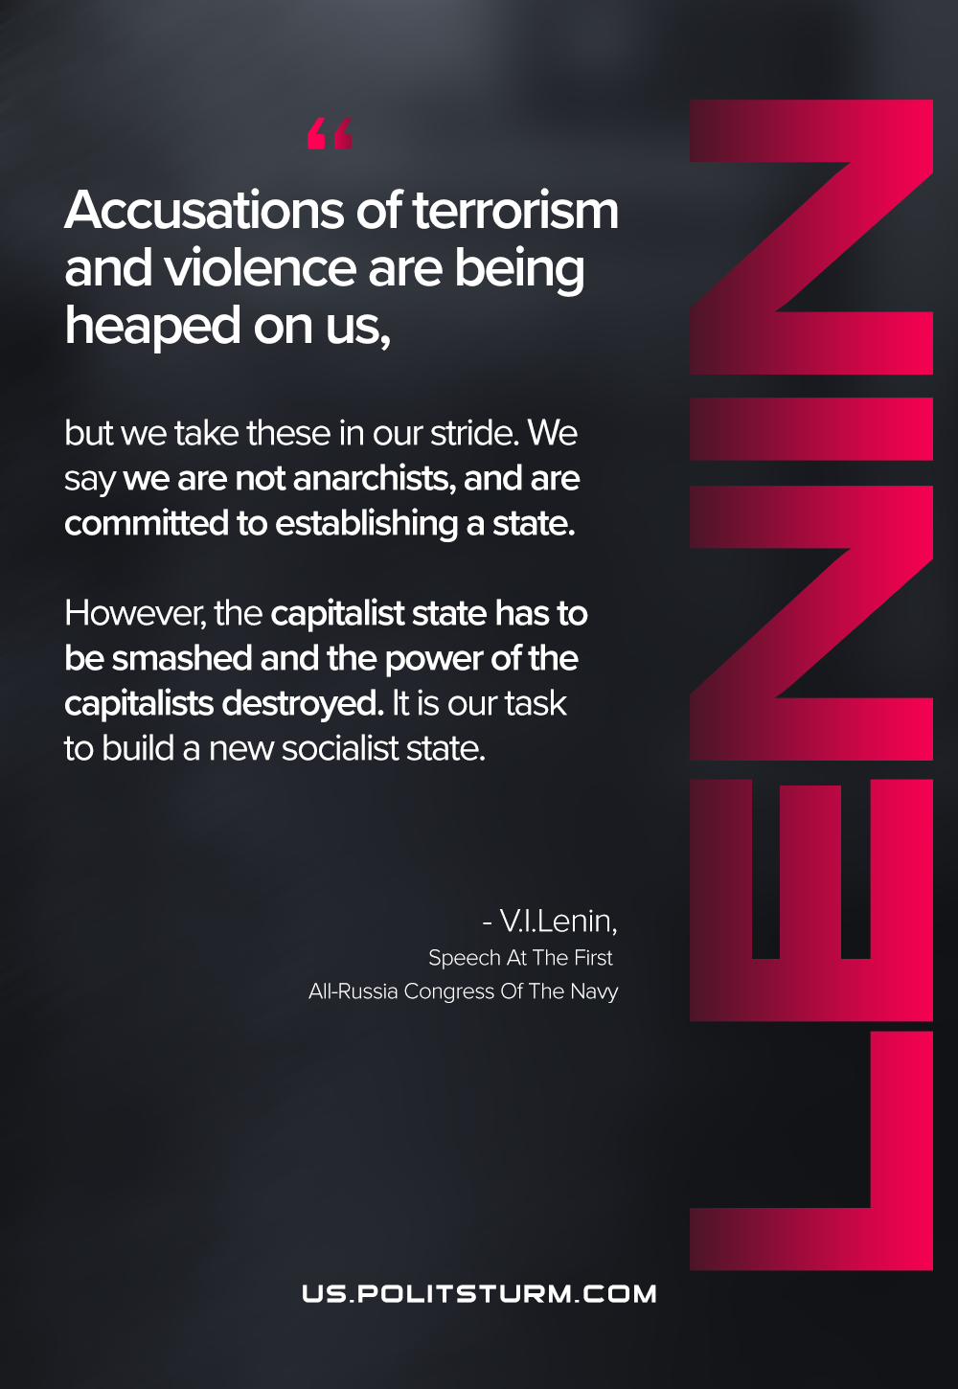

Original article
2021-01-15

“Accusations of terrorism and violence are being heaped on us, but we take these in our stride. We say we are not anarchists, and are committed to establishing a state. However, the capitalist state has to be smashed and the power of the capitalists destroyed. It is our task to build a new socialist state.
Vladimir Lenin, “Speech At The First All-Russia Congress Of The Navy”

Original article

