Lenin on Communist Party
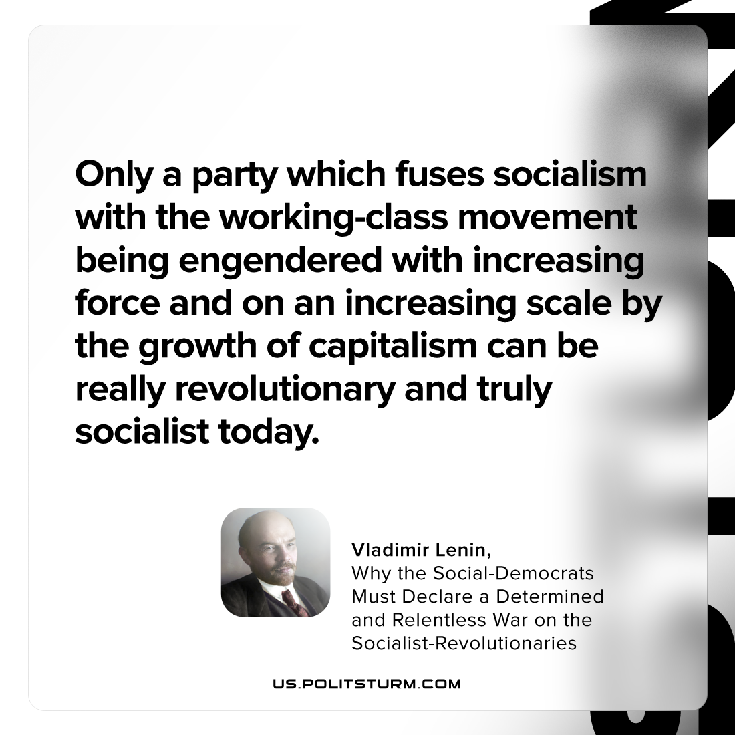

Original article
2023-06-20

"Only a party which fuses socialism with the working-class movement being engendered with increasing force and on an increasing scale by the growth of capitalism can be really revolutionary and truly socialist today."
Vladimir Lenin, Why the Social-Democrats Must Declare a Determined and Relentless War on the Socialist-Revolutionaries

Original article

