Lenin on Combining Revolutionary and Opportunist Elements Leading to Problems
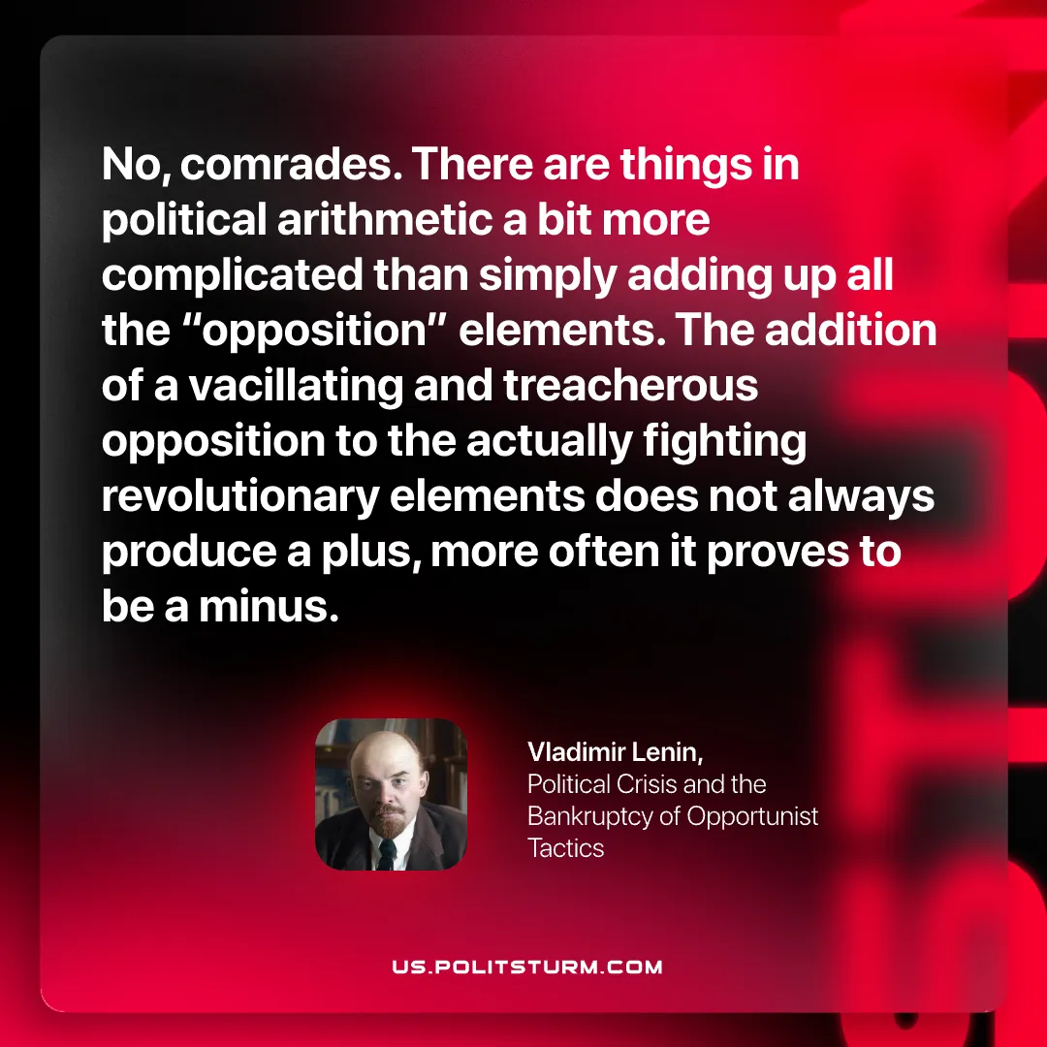

Original article
2026-01-11

“No, comrades. There are things in political arithmetic a bit more complicated than simply adding up all the “opposition” elements. The addition of a vacillating and treacherous opposition to the actually fighting revolutionary elements does not always produce a plus, more often it proves to be a minus.”
Vladimir Lenin, Political Crisis and the Bankruptcy of Opportunist Tact

Original article

