Lenin on Combining Ideological Struggle With Discipline
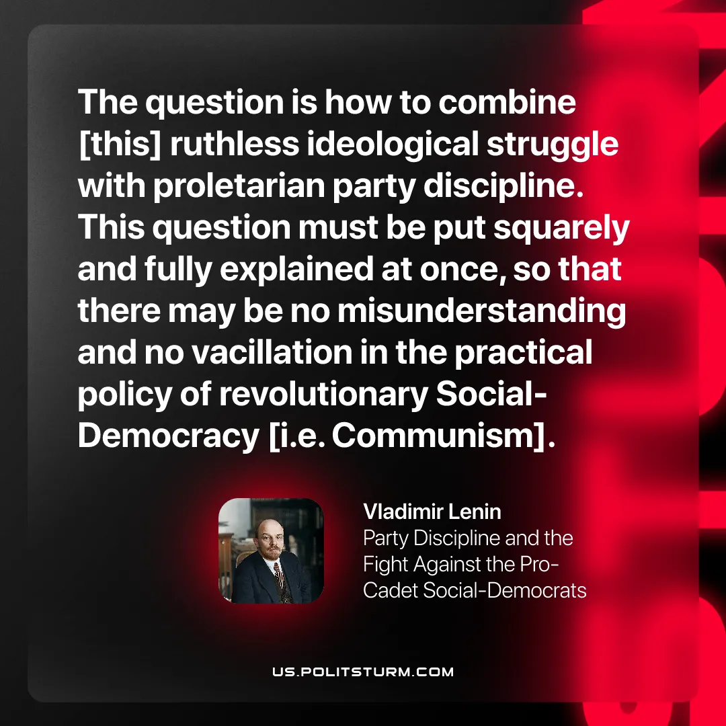

Original article
2026-01-18

“The question is how to combine [this] ruthless ideological struggle with proletarian party discipline. This question must be put squarely and fully explained at once, so that there may be no misunderstanding and no vacillation in the practical policy of revolutionary Social-Democracy [i.e. Communism].”
Vladimir Lenin, Party Discipline and the Fight Against the Pro-Cadet Social-Democrats

Original article

