Lenin on Combating Religion
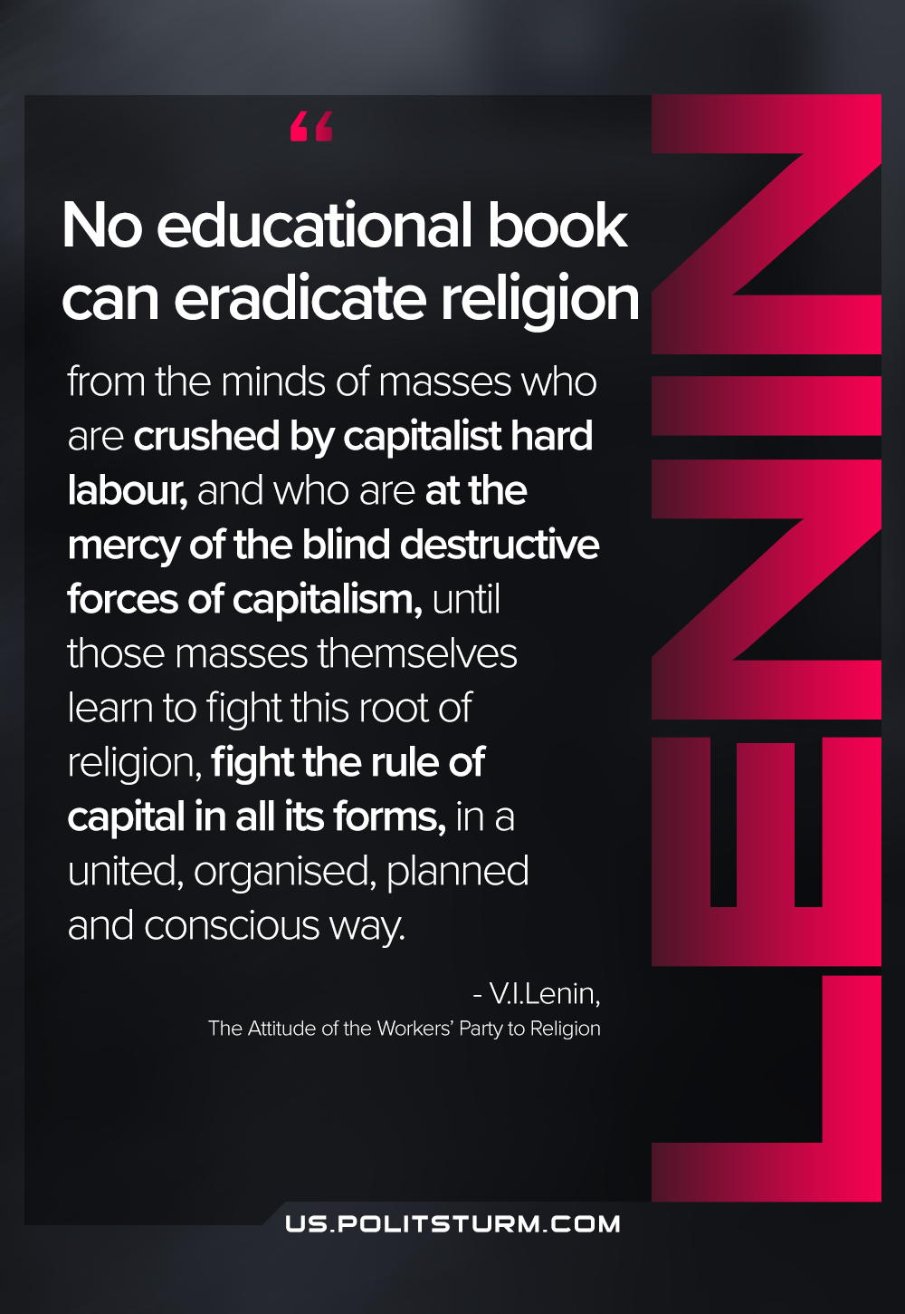

Original article
2021-04-18

No educational book can eradicate religion from the minds of masses who are crushed by capitalist hard labour, and who are at the mercy of the blind destructive forces of capitalism, until those masses themselves learn to fight this root of religion, fight the rule of capital in all its forms, in a united, organised, planned and conscious way.
The Attitude of the Workers’ Party to Religion

Original article

