Lenin on Class Tasks of Proletariat
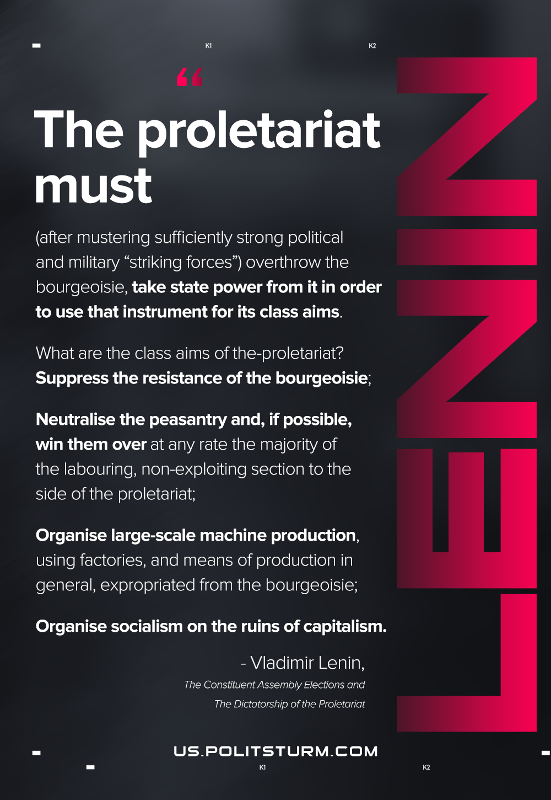

Original article
2021-03-25
1 min read

The proletariat must (after mustering sufficiently strong political and military “striking forces”) overthrow the bourgeoisie, take state power from it in order to use that instrument for its class aims.
What are the class aims of the-proletariat?
Suppress the resistance of the bourgeoisie;
Neutralise the peasantry and, if possible, win them over at any rate the majority of the labouring, non-exploiting section to the side of the proletariat;
Organise large-scale machine production, using factories, and means of production in general, expropriated from the bourgeoisie;
Organise socialism on the ruins of capitalism.
“The Constituent Assembly Elections and The Dictatorship of the Proletariat”

Original article

