Lenin on Class Struggle
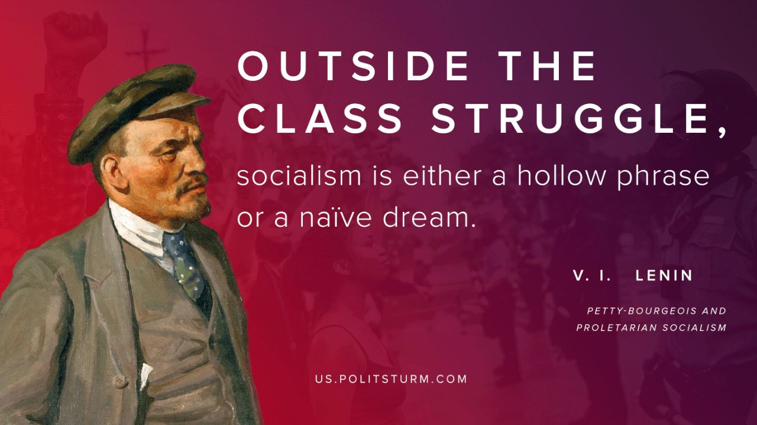

Original article
2020-06-30

“Outside the class struggle, socialism is either a hollow phrase or a naive dream”
V. I. Lenin
Petty-Bourgeois and Proletarian Socialism

Original article

