Lenin on Class Struggle and Revolution
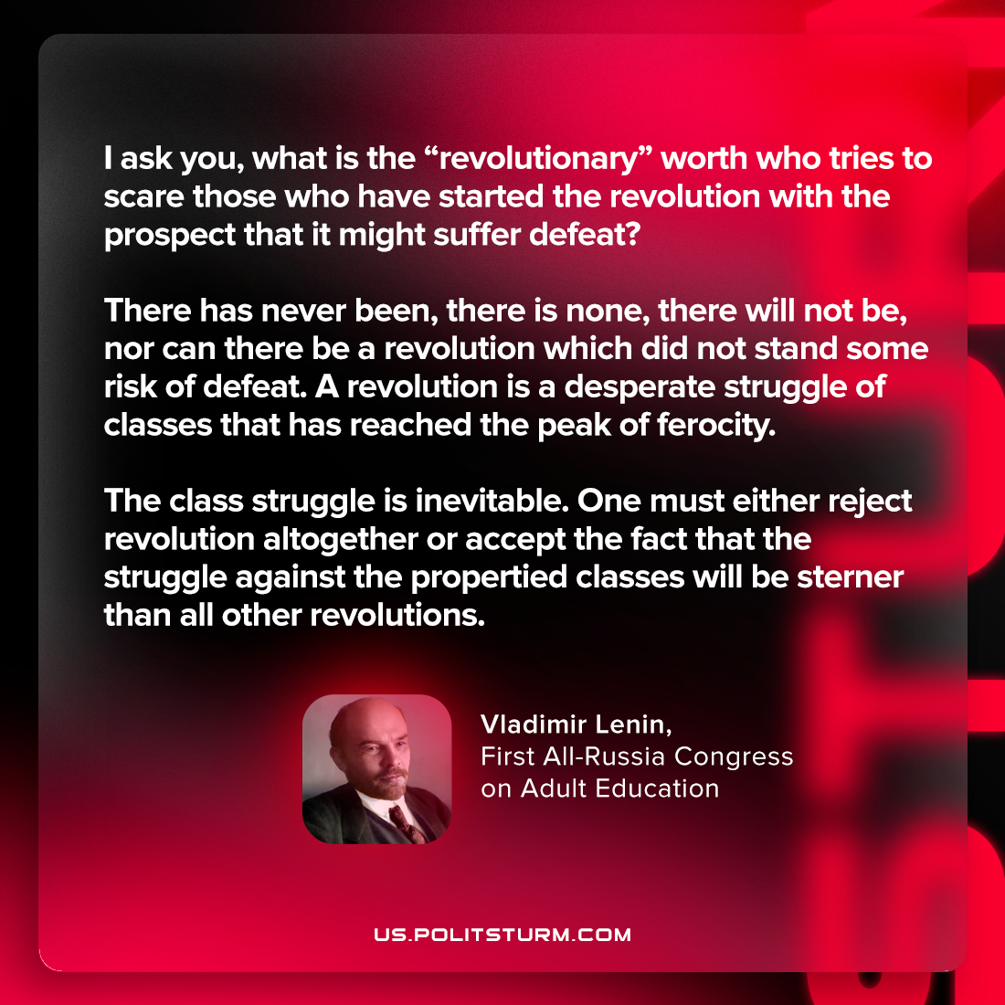

Original article
2023-01-15
1 min read

"I ask you, what is the “revolutionary” worth who tries to scare those who have started the revolution with the prospect that it might suffer defeat? There has never been, there is none, there will not be, nor can there be a revolution which did not stand some risk of defeat. A revolution is a desperate struggle of classes that has reached the peak of ferocity. The class struggle is inevitable. One must either reject revolution altogether or accept the fact that the struggle against the propertied classes will be sterner than all other revolutions."
Vladimir Lenin, First All-Russia Congress on Adult Education

Original article

