Lenin on Class Struggle and Democracy
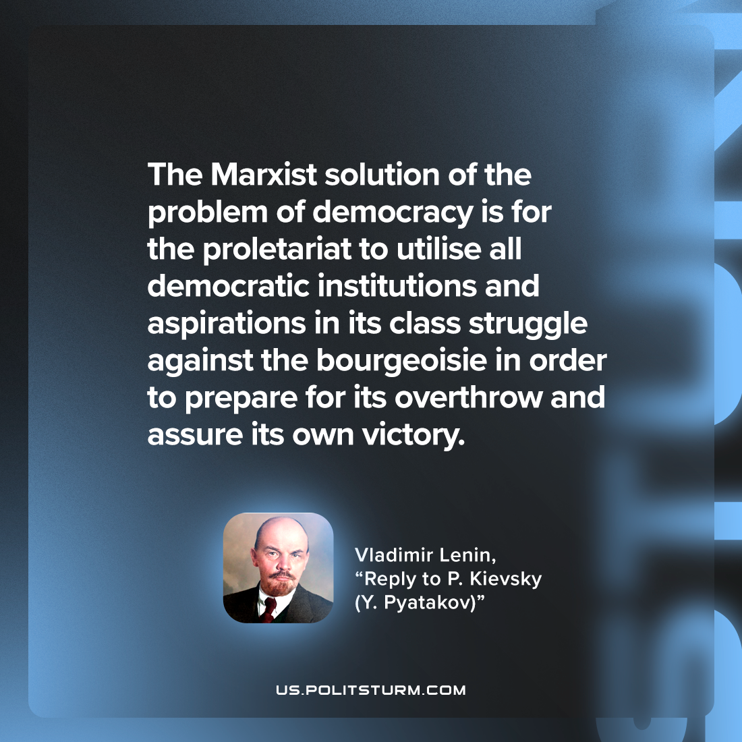

Original article
2022-12-17

"The Marxist solution of the problem of democracy is for the proletariat to utilise all democratic institutions and aspirations in its class struggle against the bourgeoisie in order to prepare for its overthrow and assure its own victory."
Vladimir Lenin, “Reply to P. Kievsky (Y. Pyatakov)”

Original article

