Lenin on Class Depiction of Reality
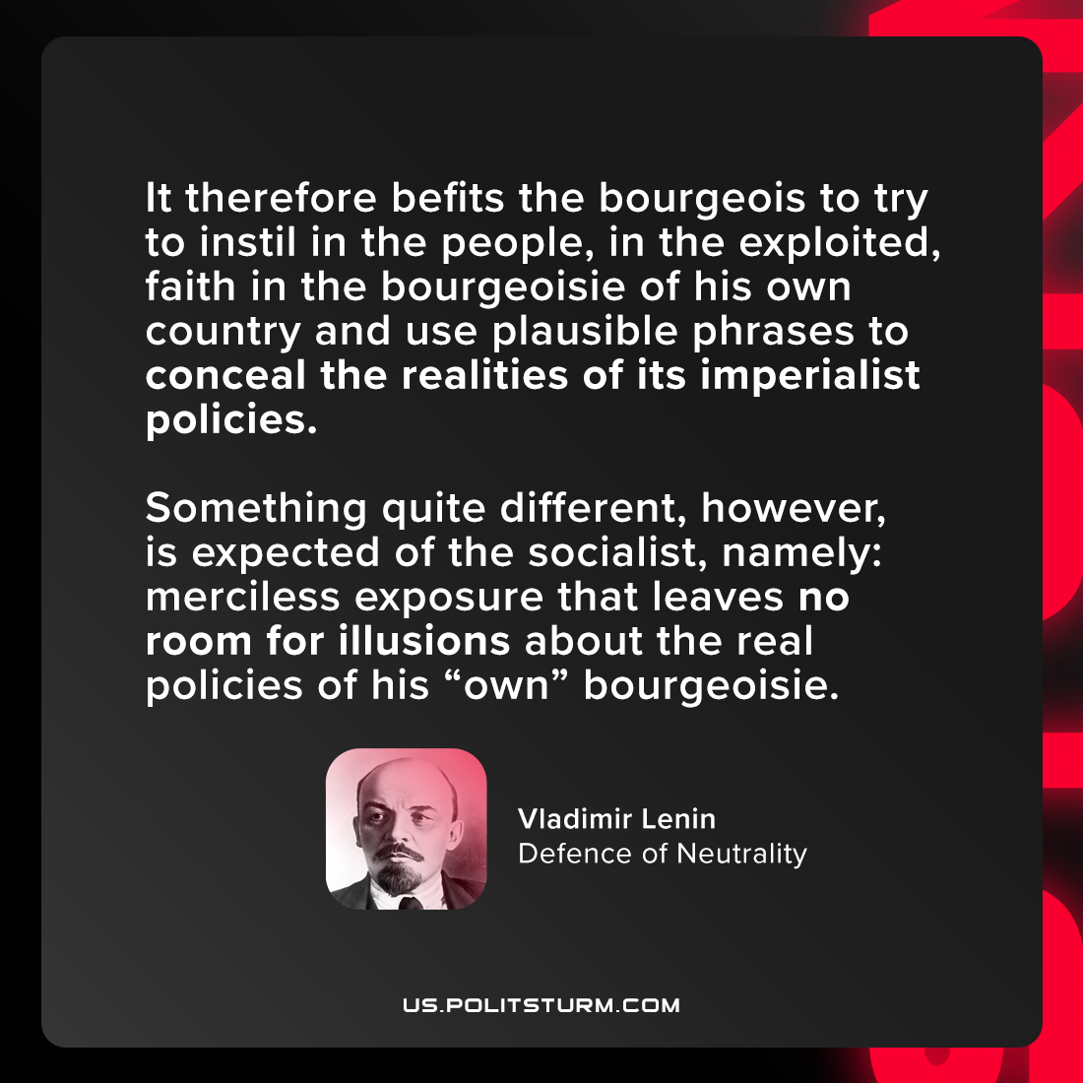

Original article
2021-07-20

It therefore befits the bourgeois to try to instil in the people, in the exploited, faith in the bourgeoisie of his own country and use plausible phrases to conceal the realities of its imperialist policies. Something quite different, however, is expected of the socialist, namely: merciless exposure that leaves no room for illusions about the real policies of his “own” bourgeoisie.
Vladimir Lenin, “Defence of Neutrality”

Original article

