Lenin on Class Collaboration
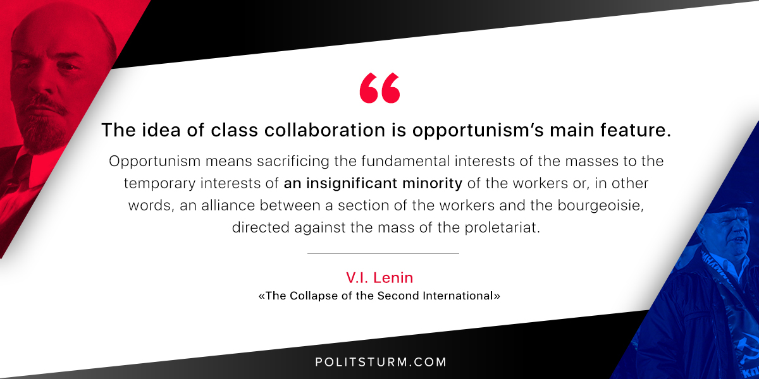

Original article
2018-07-06

“The idea of class collaboration is opportunism’s main feature. Opportunism means sacrificing the fundamental interests of the masses to the temporary interests of an insignificant minority of the workers or, in other words, an alliance between a section of the workers and the bourgeoisie, directed against the mass of the proletariat.”
V.I. Lenin, “The Collapse of the Second International”

Original article

