Lenin on "Civilising" Enterprises
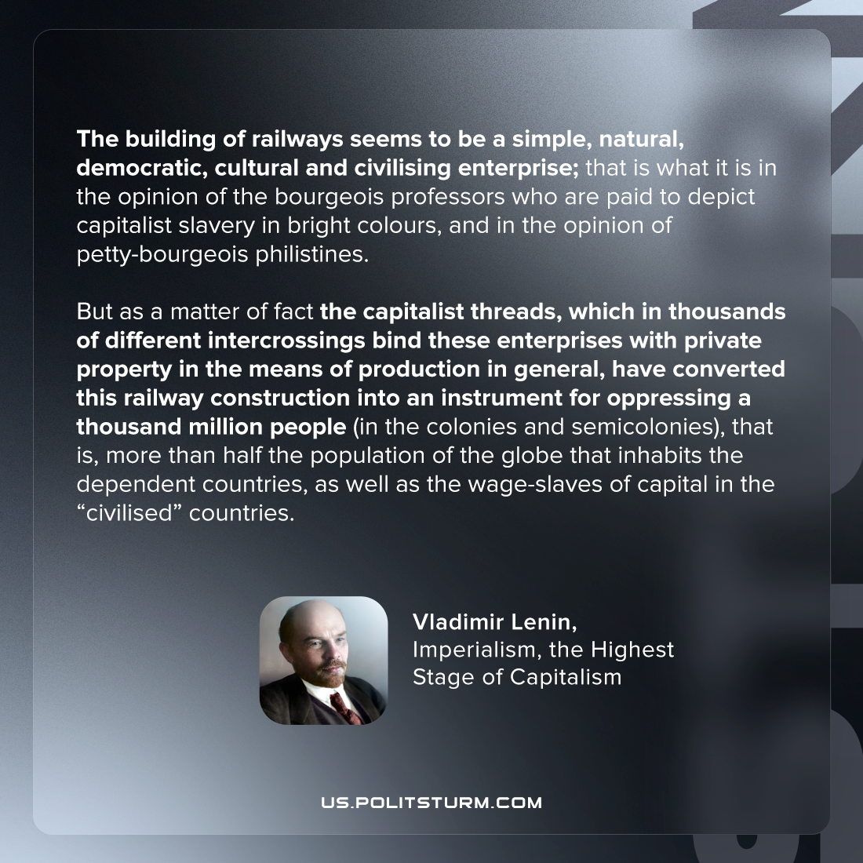

Original article
2022-10-30
1 min read

The building of railways seems to be a simple, natural, democratic, cultural and civilising enterprise; that is what it is in the opinion of the bourgeois professors who are paid to depict capitalist slavery in bright colours, and in the opinion of petty-bourgeois philistines. But as a matter of fact the capitalist threads, which in thousands of different intercrossings bind these enterprises with private property in the means of production in general, have converted this railway construction into an instrument for oppressing a thousand million people (in the colonies and semicolonies), that is, more than half the population of the globe that inhabits the dependent countries, as well as the wage-slaves of capital in the “civilised” countries.

Vladimir Lenin, “Imperialism, the Highest Stage of Capitalism”

Original article

