Lenin on Civilised Europe and it's Backwards Ruling Class
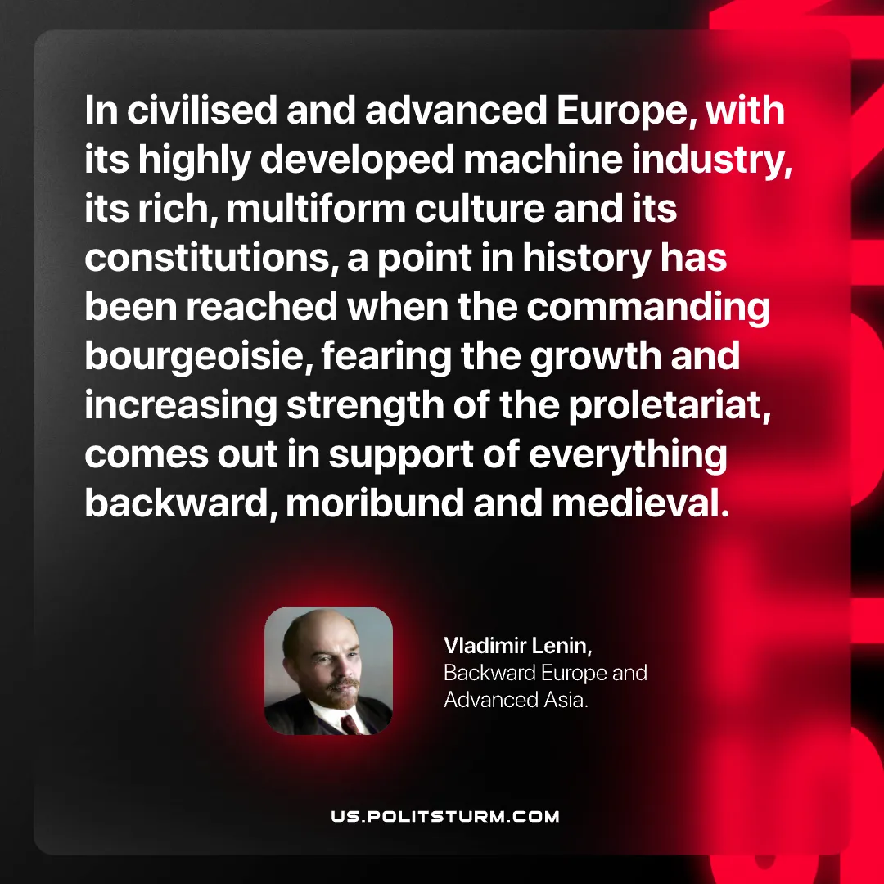

Original article
2026-07-19

In civilised and advanced Europe, with its highly developed machine industry, its rich, multiform culture and its constitutions, a point in history has been reached when the commanding bourgeoisie, fearing the growth and increasing strength of the proletariat, comes out in support of everything backward, moribund and medieval.
Vladimir Lenin, Backward Europe and Advanced Asia.

Original article

