Lenin on Civil War
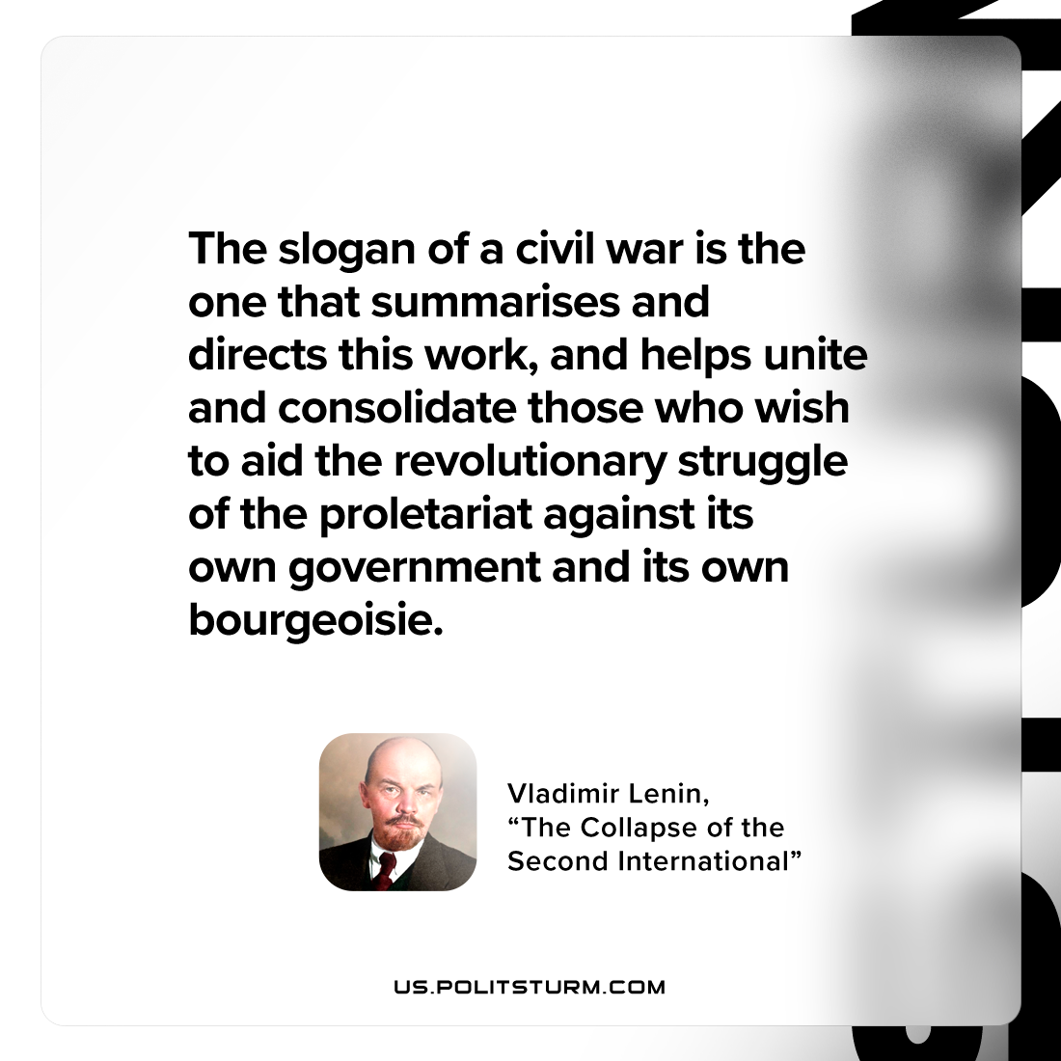

Original article
2023-01-12

"The slogan of a civil war is the one that summarises and directs this work, and helps unite and consolidate those who wish to aid the revolutionary struggle of the proletariat against its own government and its own bourgeoisie."
Vladimir Lenin, “The Collapse of the Second International”

Original article

