Lenin on Chauvinists
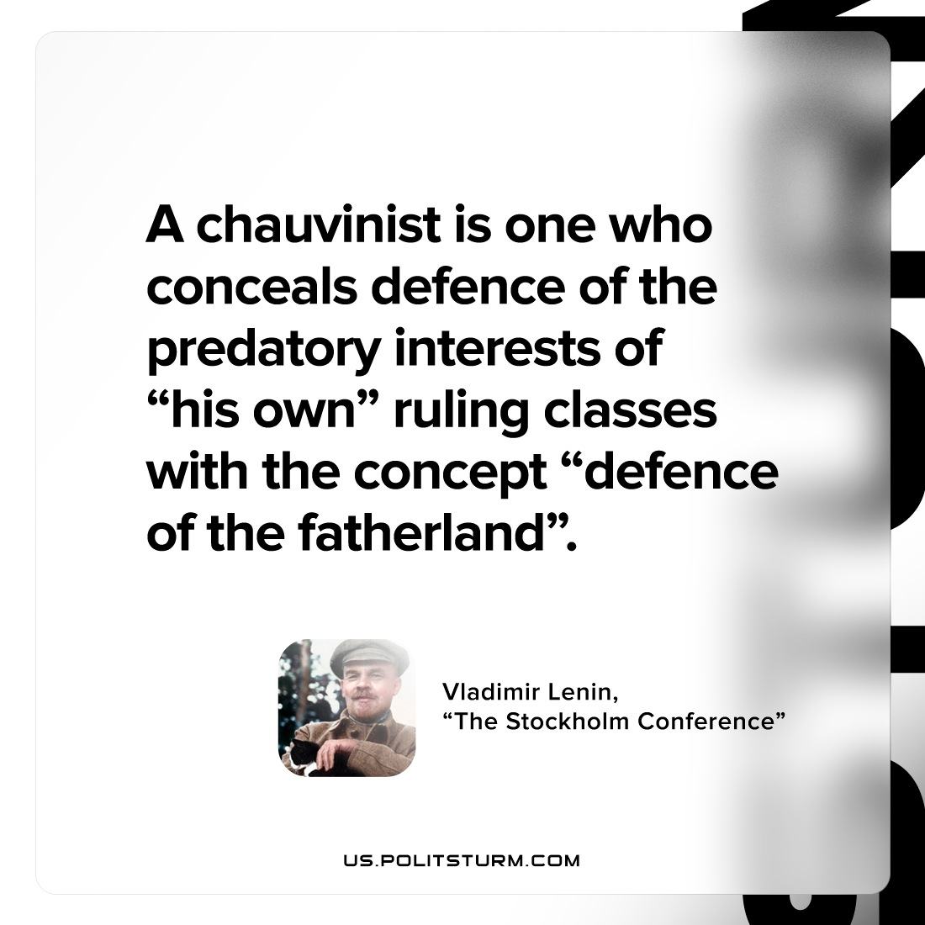

Original article
2022-08-30

A chauvinist is one who conceals defence of the predatory interests of “his own” ruling classes with the concept “defence of the fatherland”.

Vladimir Lenin, “The Stockholm Conference”

Original article

