Lenin on Certain Groups and the Lie About the State
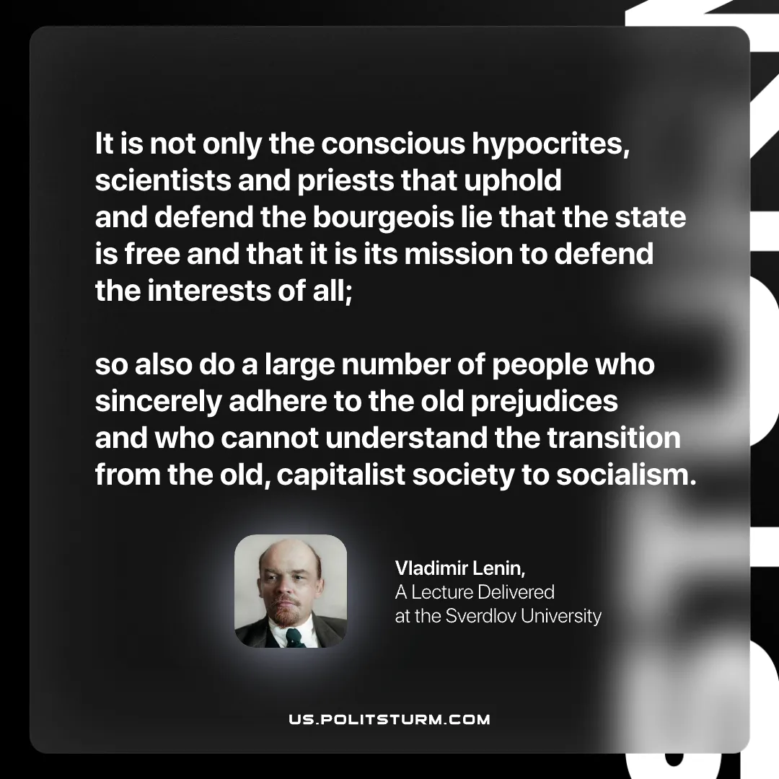

Original article
2026-02-21

“It is not only the conscious hypocrites, scientists and priests that uphold and defend the bourgeois lie that the state is free and that it is its mission to defend the interests of all; so also do a large number of people who sincerely adhere to the old prejudices and who cannot understand the transition from the old, capitalist society to socialism.
Vladimir Lenin, A Lecture Delivered at the Sverdlov University

Original article

