Lenin on Capitalist Peace Used to Divert the Worker Struggle
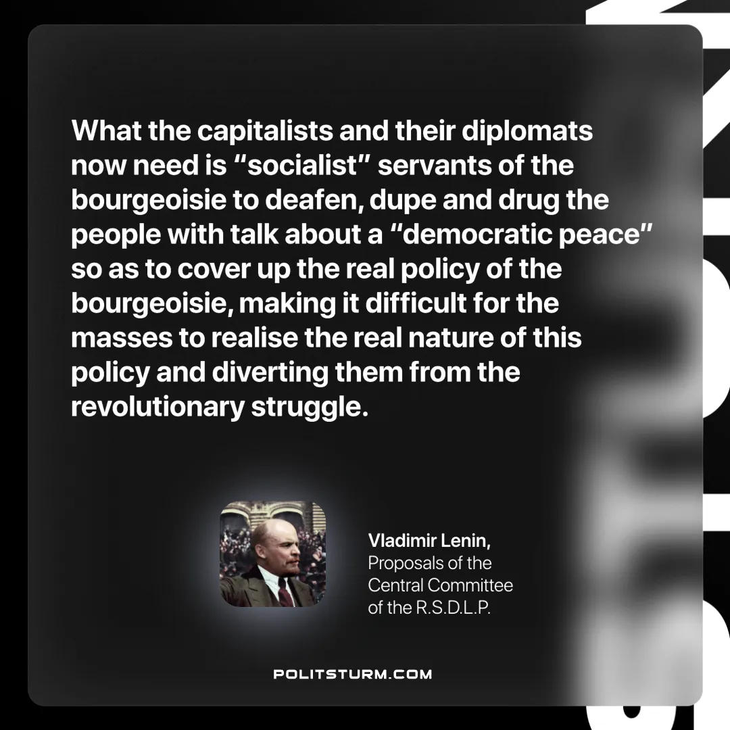

Original article
2025-05-25

“What the capitalists and their diplomats now need is “socialist” servants of the bourgeoisie to deafen, dupe and drug the people with talk about a “democratic peace” so as to cover up the real policy of the bourgeoisie, making it difficult for the masses to realise the real nature of this policy and diverting them from the revolutionary struggle.”
Vladimir Lenin, Proposals of the Central Committee of the R.S.D.L.P

Original article

