Lenin on Capitalist Military Spending
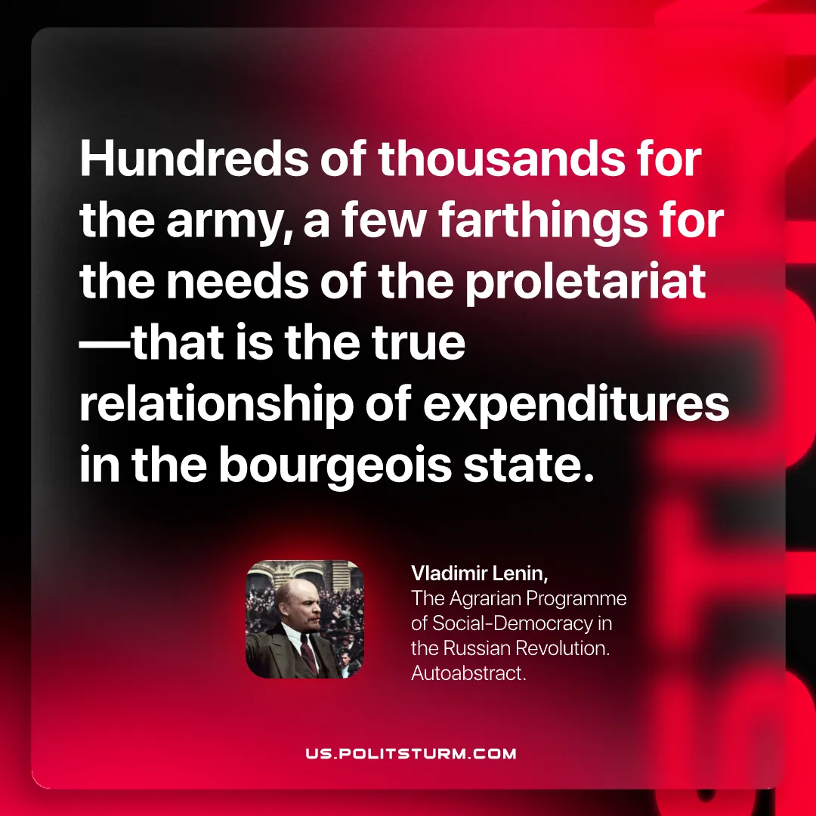

Original article
2026-06-21

Hundreds of thousands for the army, a few farthings for the needs of the proletariat —that is the true relationship of expenditures in the bourgeois state.
Vladimir Lenin, The Agrarian Programme of Social‑Democracy in the Russian Revolution. Autoabstract.

Original article

