Lenin on Capitalist Bias in Science
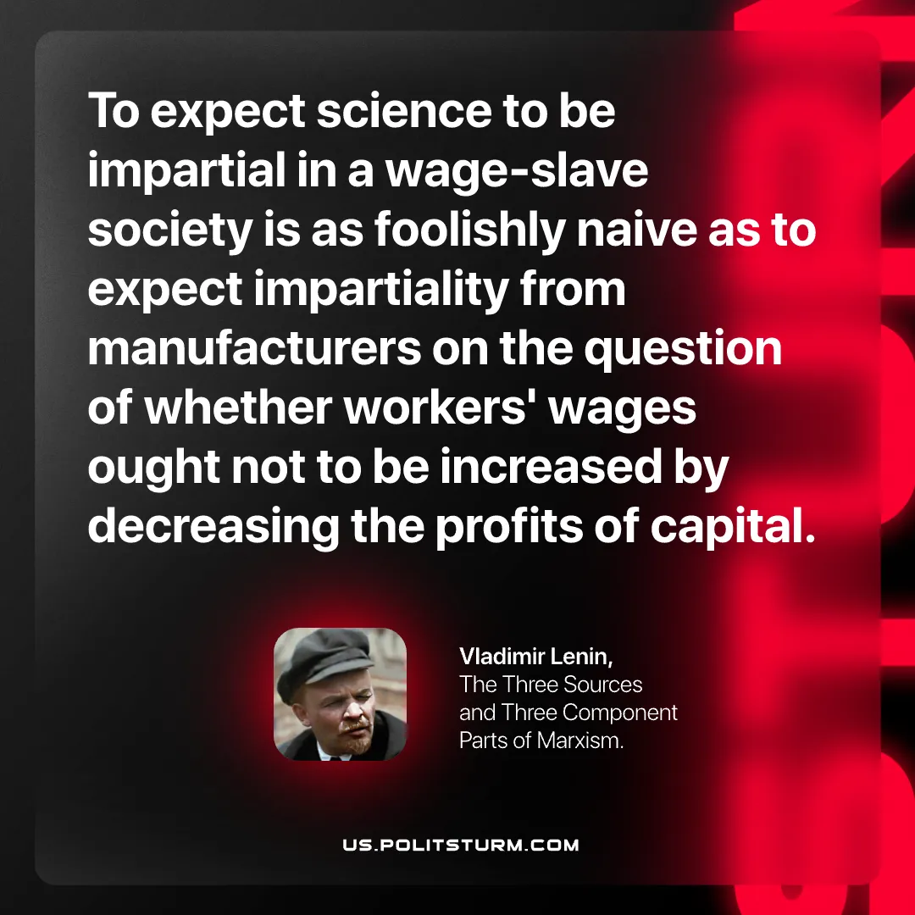

Original article
2026-07-07

To expect science to be impartial in a wage‑slave society is as foolishly naive as to expect impartiality from manufacturers on the question of whether workers' wages ought not to be increased by decreasing the profits of capital.
Vladimir Lenin, The Three Sources and Three Component Parts of Marxism.

Original article

