Lenin on Capitalism
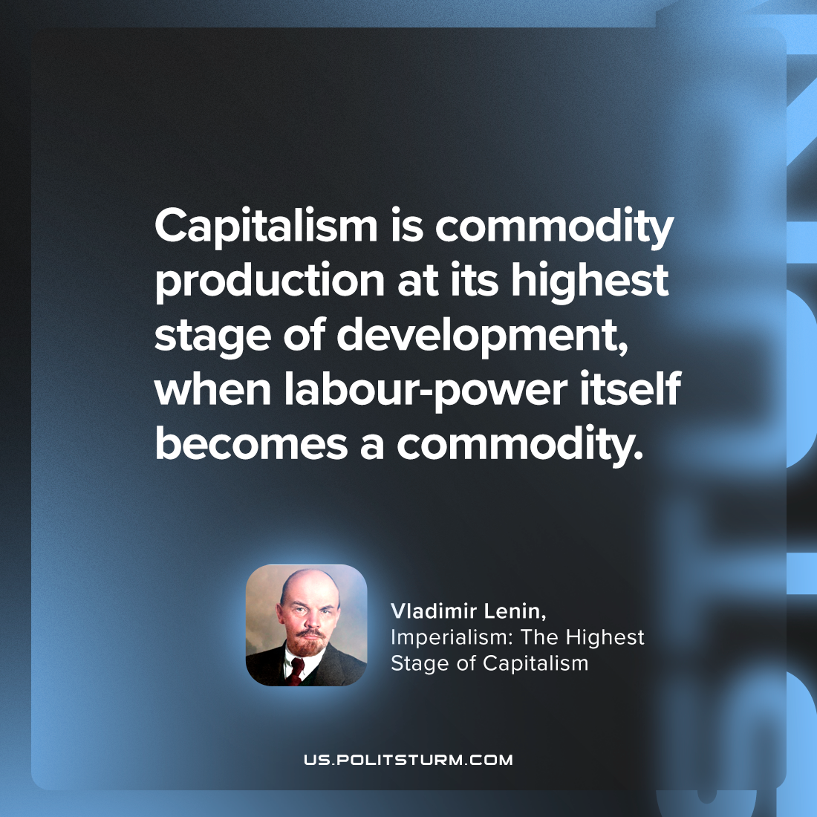

Original article
2023-10-08

"Capitalism is commodity production at its highest stage of development, when labour-power itself becomes a commodity."
Vladimir Lenin, Imperialism: the Highest Stage of Capitalism

Original article

