Lenin on Capitalism and Profits
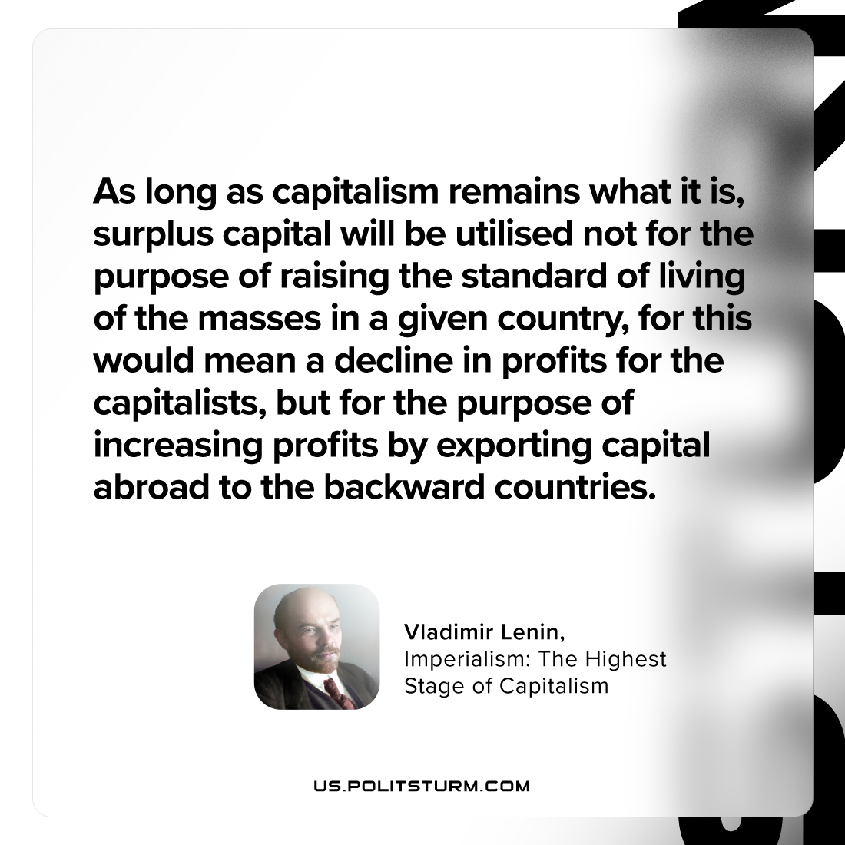

Original article
2023-10-12

"As long as capitalism remains what it is, surplus capital will be utilised not for the purpose of raising the standard of living of the masses in a given country, for this would mean a decline in profits for the capitalists, but for the purpose of increasing profits by exporting capital abroad to the backward countries."
Vladimir Lenin, Imperialism: the Highest Stage of Capitalism

Original article

