Lenin on Capitalism and Monopoly
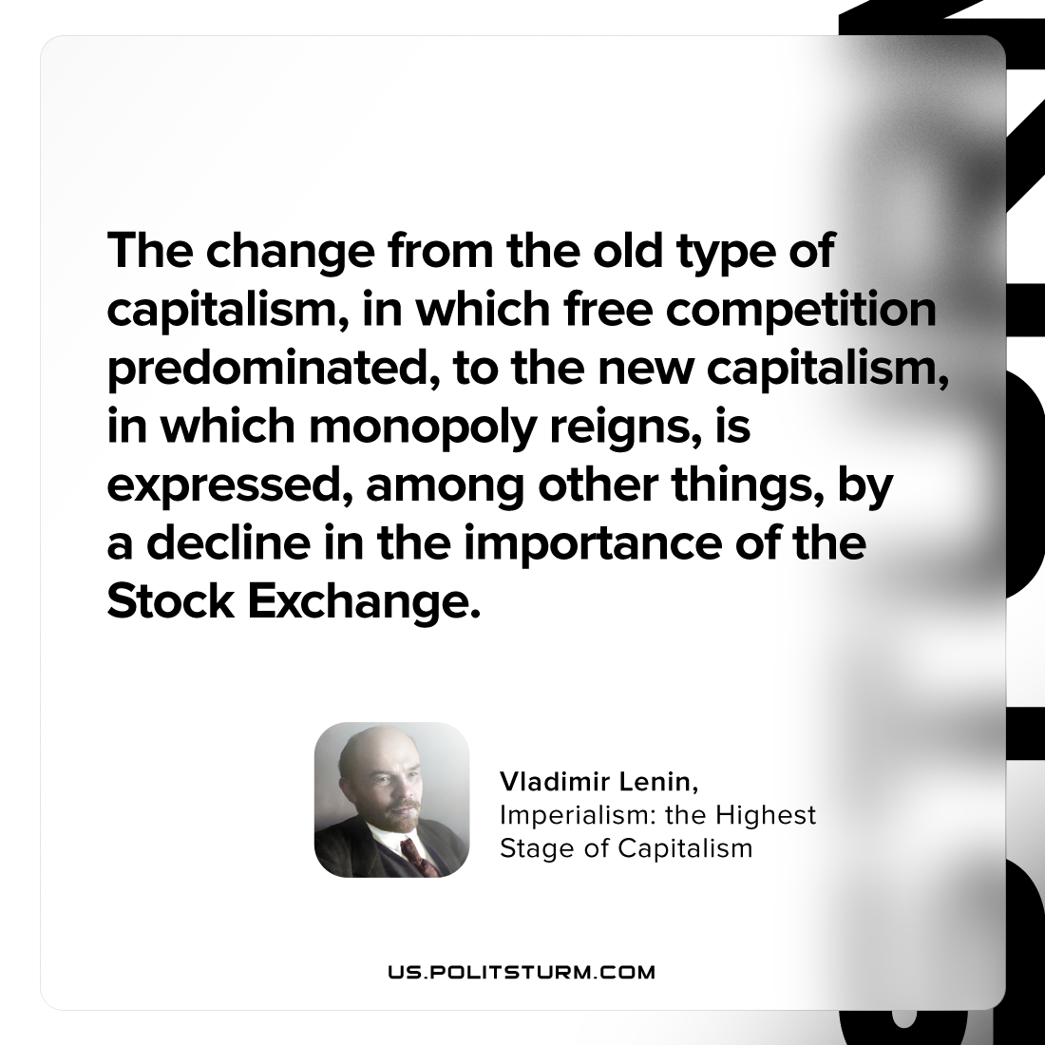

Original article
2023-07-11

"The change from the old type of capitalism, in which free competition predominated, to the new capitalism, in which monopoly reigns, is expressed, among other things, by a decline in the importance of the Stock Exchange."
Vladimir Lenin, Imperialism: the Highest Stage of Capitalism

Original article

