Lenin on Capitalism and its Development
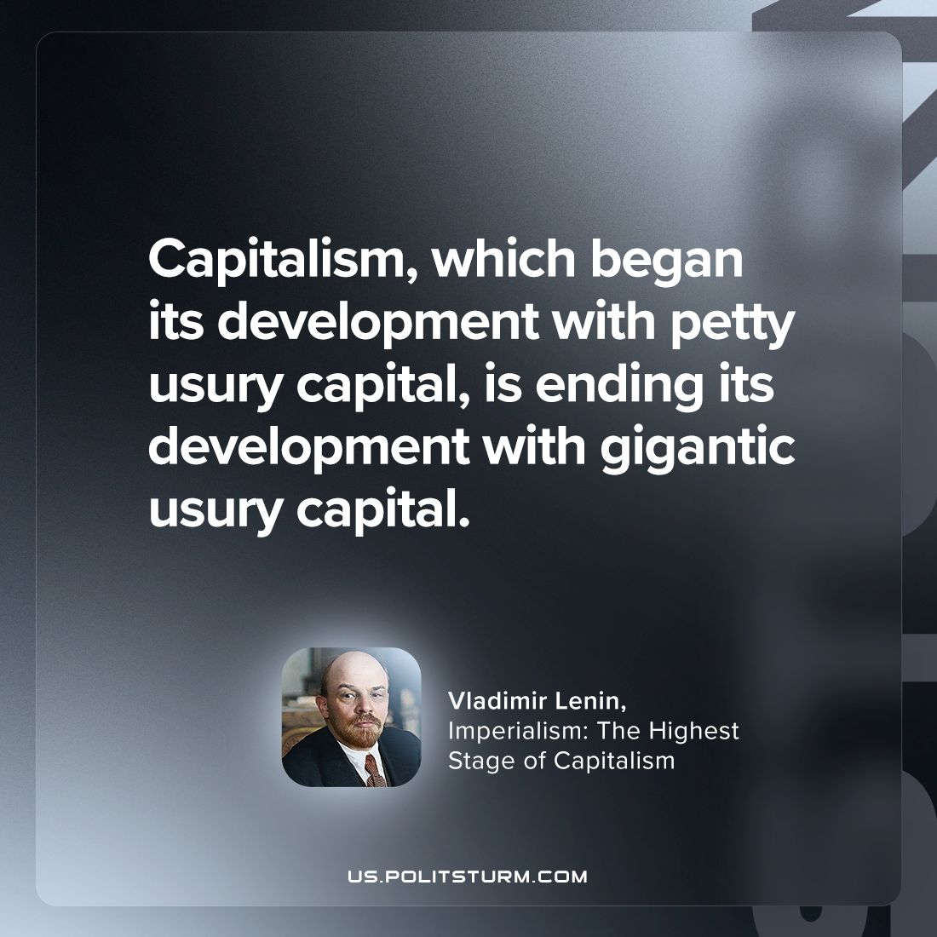

Original article
2023-08-27

"Capitalism, which began its development with petty usury capital, is ending its development with gigantic usury capital."
Vladimir Lenin, Imperialism: the Highest Stage of Capitalism

Original article

