Lenin on Capital
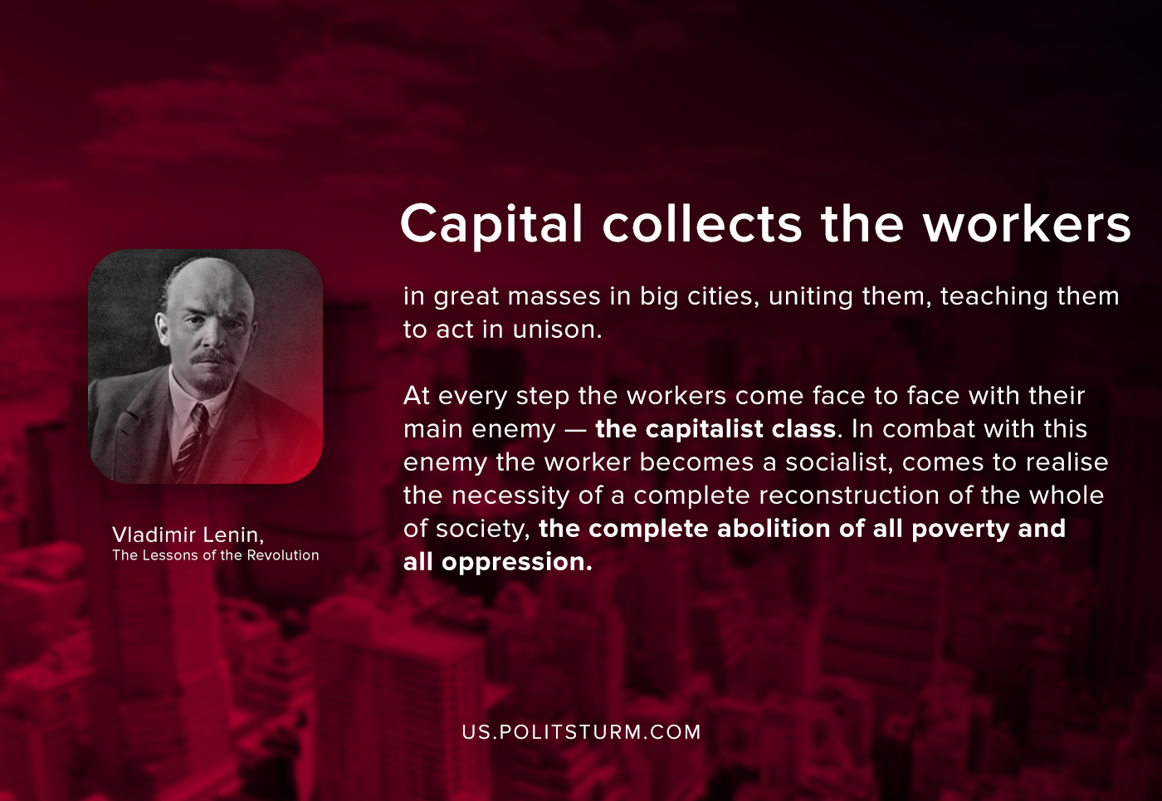

Original article
2020-10-18

Capital collects the workers in great masses in big cities, uniting them, teaching them to act in unison. At every step the workers come face to face with their main enemy — the capitalist class. In combat with this enemy the worker becomes a socialist, comes to realise the necessity of a complete reconstruction of the whole of society, the complete abolition of all poverty and all oppression.

Original article

