Lenin on Capital
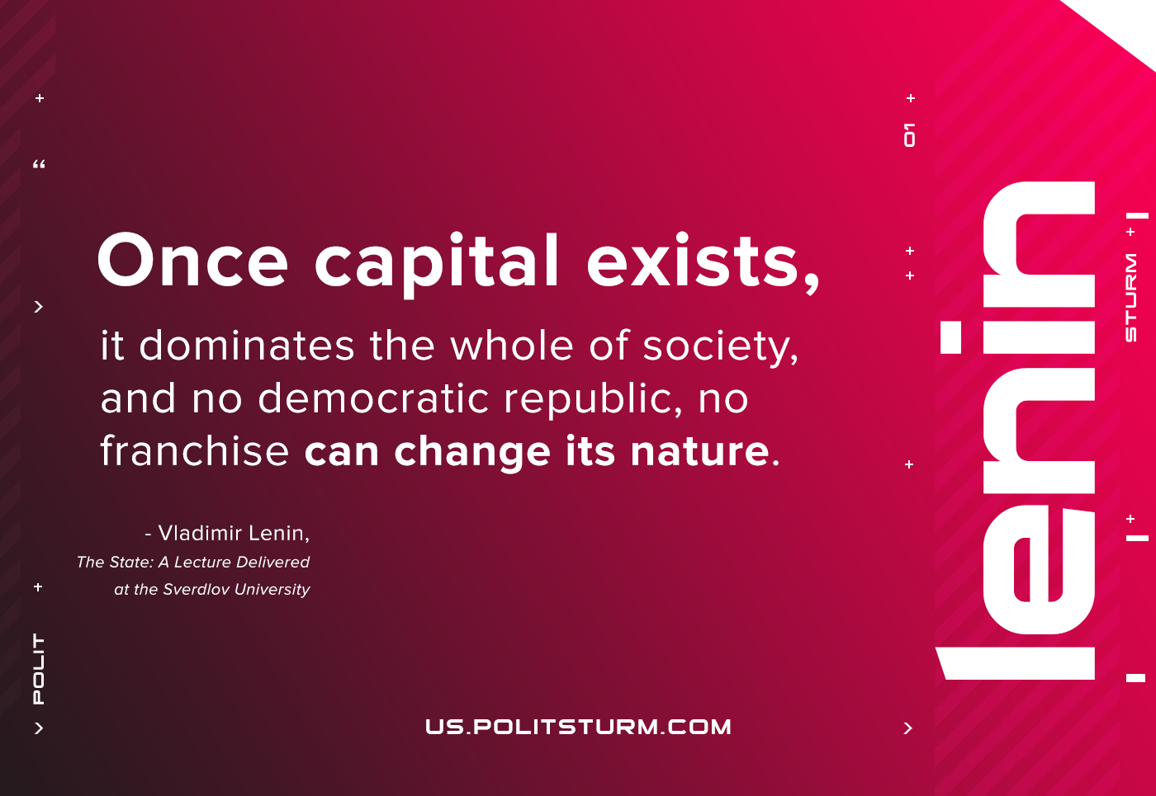

Original article
2021-04-30

Once capital exists, it dominates the whole of society, and no democratic republic, no franchise can change its nature.
The State: A Lecture Delivered at the Sverdlov University

Original article

