Lenin on Bourgeois Subversion of Goals
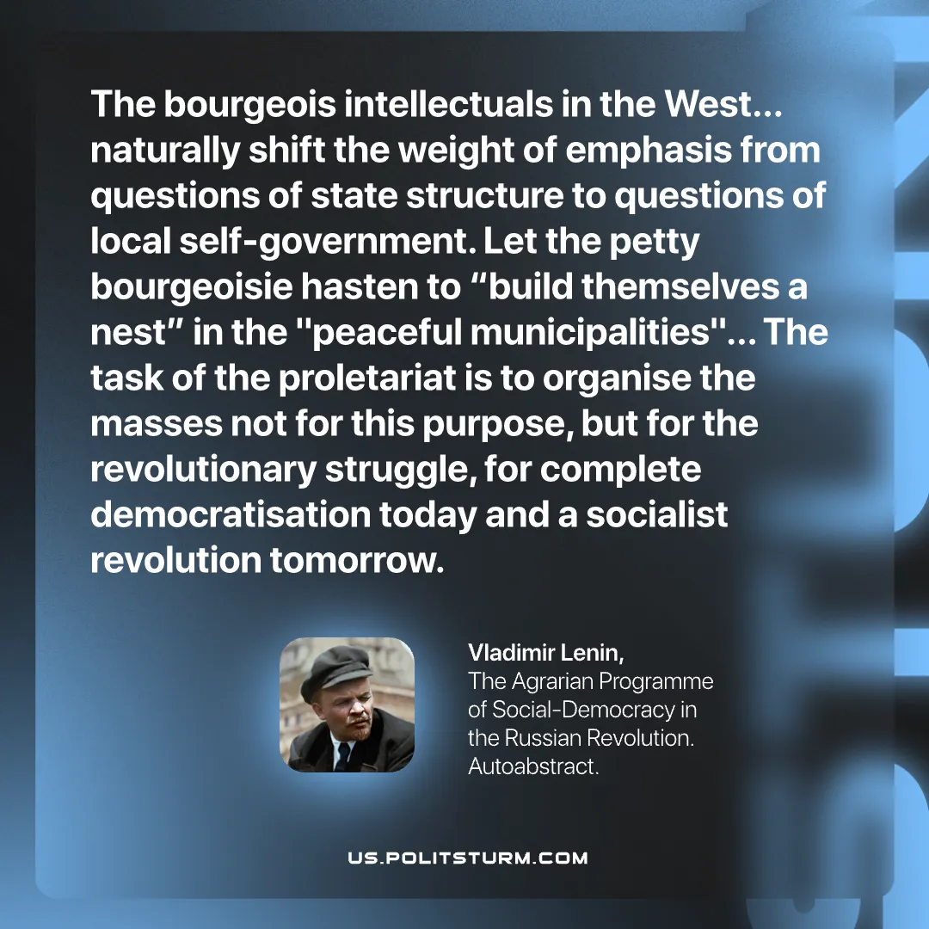

Original article
2026-06-18

The bourgeois intellectuals in the West… naturally shift the weight of emphasis from questions of state structure to questions of local self‑government. Let the petty bourgeoisie hasten to "build themselves a nest" in the "peaceful municipalities"… The task of the proletariat is to organise the masses not for this purpose, but for the revolutionary struggle, for complete democratisation today and a socialist revolution tomorrow.
Vladimir Lenin, The Agrarian Programme of Social‑Democracy in the Russian Revolution. Autoabstract.

Original article

