Lenin on the Impossibility of Indifference towards Class Struggle
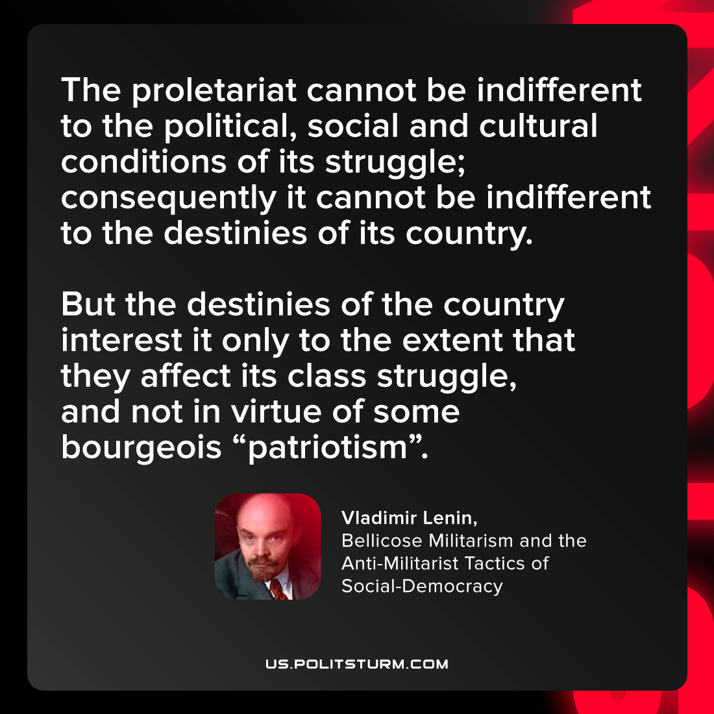

Original article
2022-03-04

The proletariat cannot be indifferent to the political, social and cultural conditions of its struggle; consequently it cannot be indifferent to the destinies of its country. But the destinies of the country interest it only to the extent that they affect its class struggle, and not in virtue of some bourgeois “patriotism”.

Vladimir Lenin, “Bellicose Militarism and the Anti-Militarist Tactics of Social-Democracy”

Original article

