Lenin on Bourgeois Parties
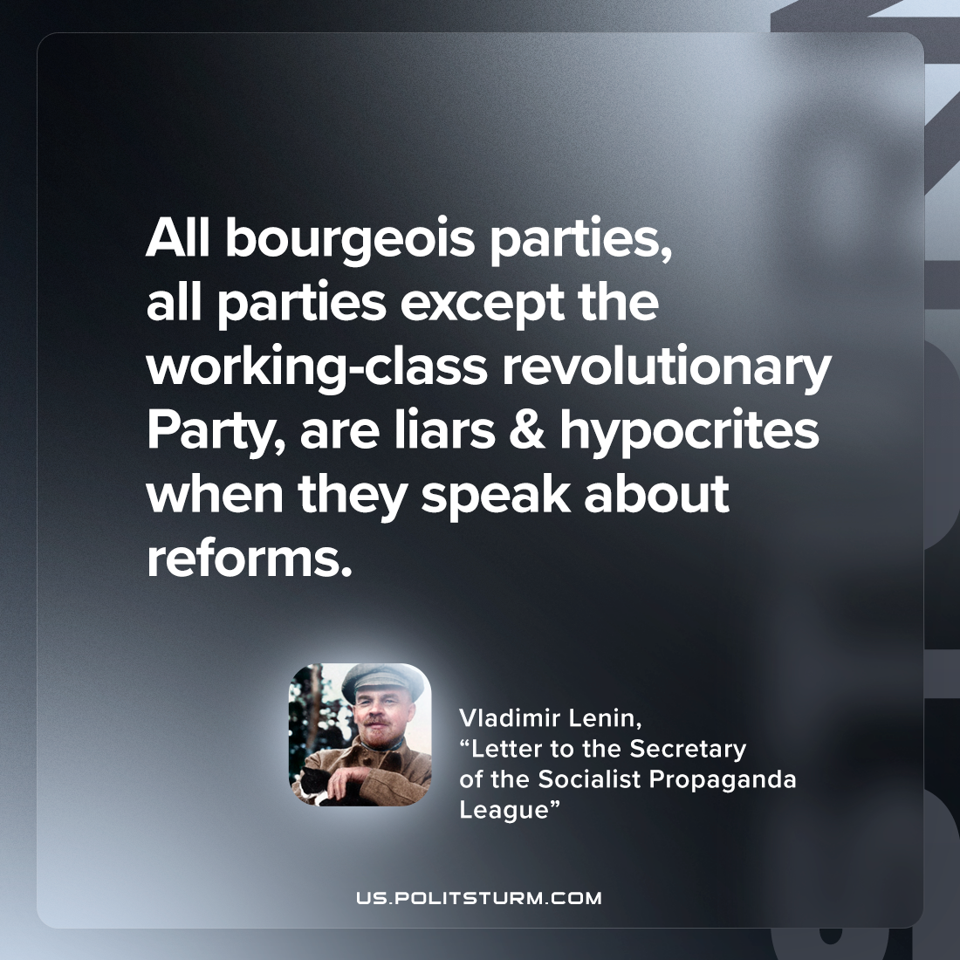

Original article
2023-04-02

"All bourgeois parties, all parties except the working-class revolutionary Party, are liars & hypocrites when they speak about reforms.
Vladimir Lenin, “Letter to the Secretary of the Socialist Propaganda League”

Original article

