Lenin on Bourgeois Parliamentarism
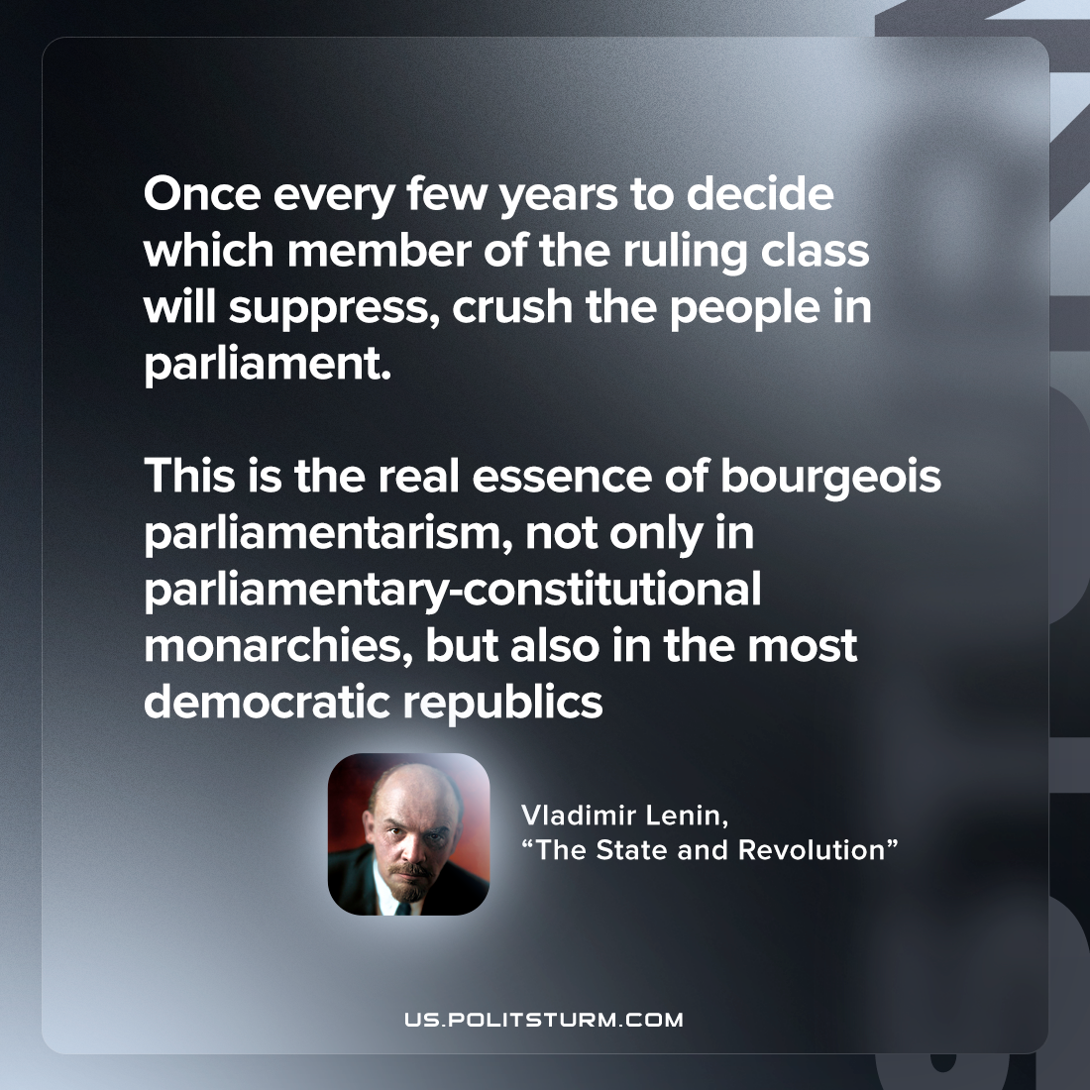

Original article
2023-05-20

"Once every few years to decide which member of the ruling class will suppress, crush the people in parliament – this is the real essence of bourgeois parliamentarism, not only in parliamentary-constitutional monarchies, but also in the most democratic republics."
Vladimir Lenin, “The State and Revolution”

Original article

