Lenin on Bourgeois Press
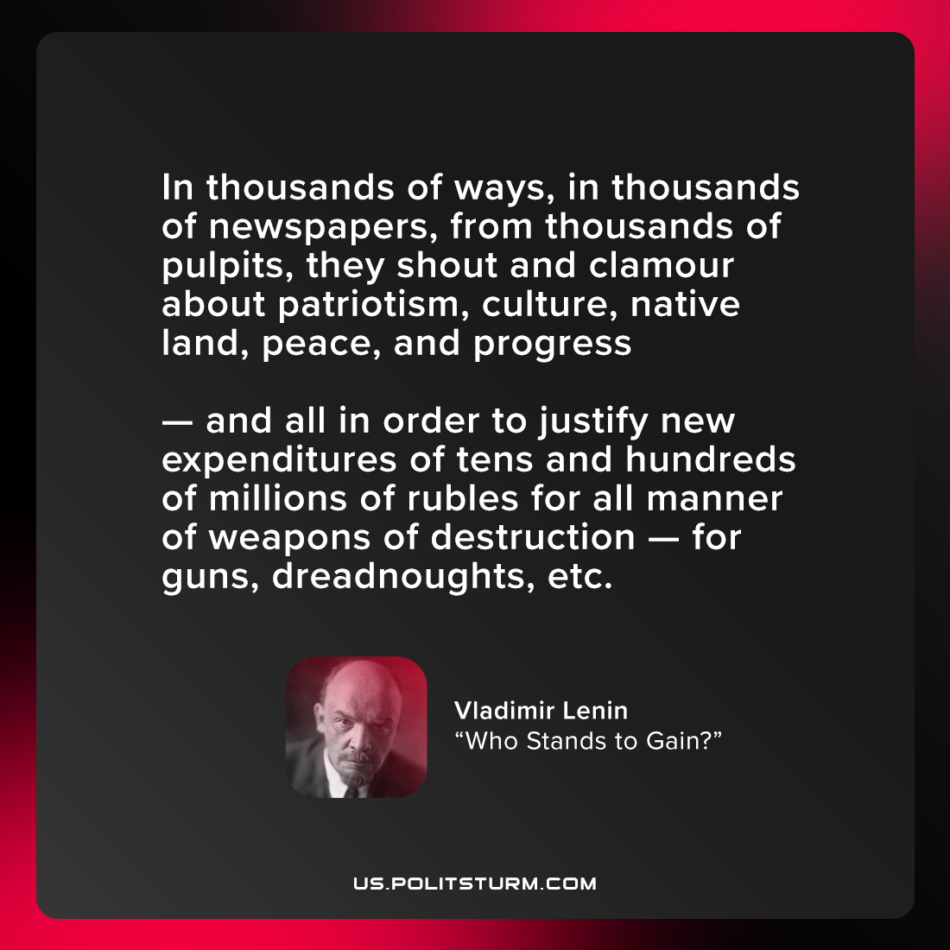

Original article
2021-08-29

In thousands of ways, in thousands of newspapers, from thousands of pulpits, they shout and clamour about patriotism, culture, native land, peace, and progress—and all in order to justify new expenditures of tens and hundreds of millions of rubles for all manner of weapons of destruction—for guns, dreadnoughts, etc.

Vladimir Lenin, “Who Stands to Gain?”

Original article

