Lenin on Bourgeois Defence of Class Interests
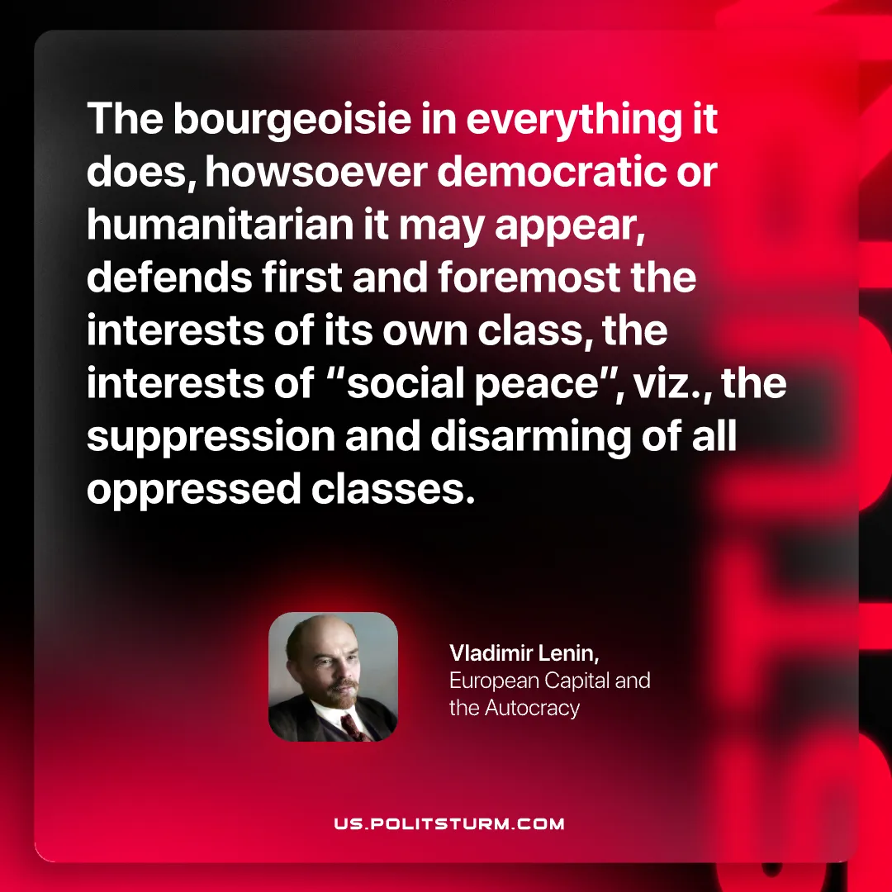

Original article
2026-09-26

The bourgeoisie in everything it does, howsoever democratic or humanitarian it may appear, defends first and foremost the interests of its own class, the interests of "social peace", viz., the suppression and disarming of all oppressed classes.
Vladimir Lenin, European Capital and the Autocracy

Original article

