Lenin on Bolshevik Revolution and Women Rights
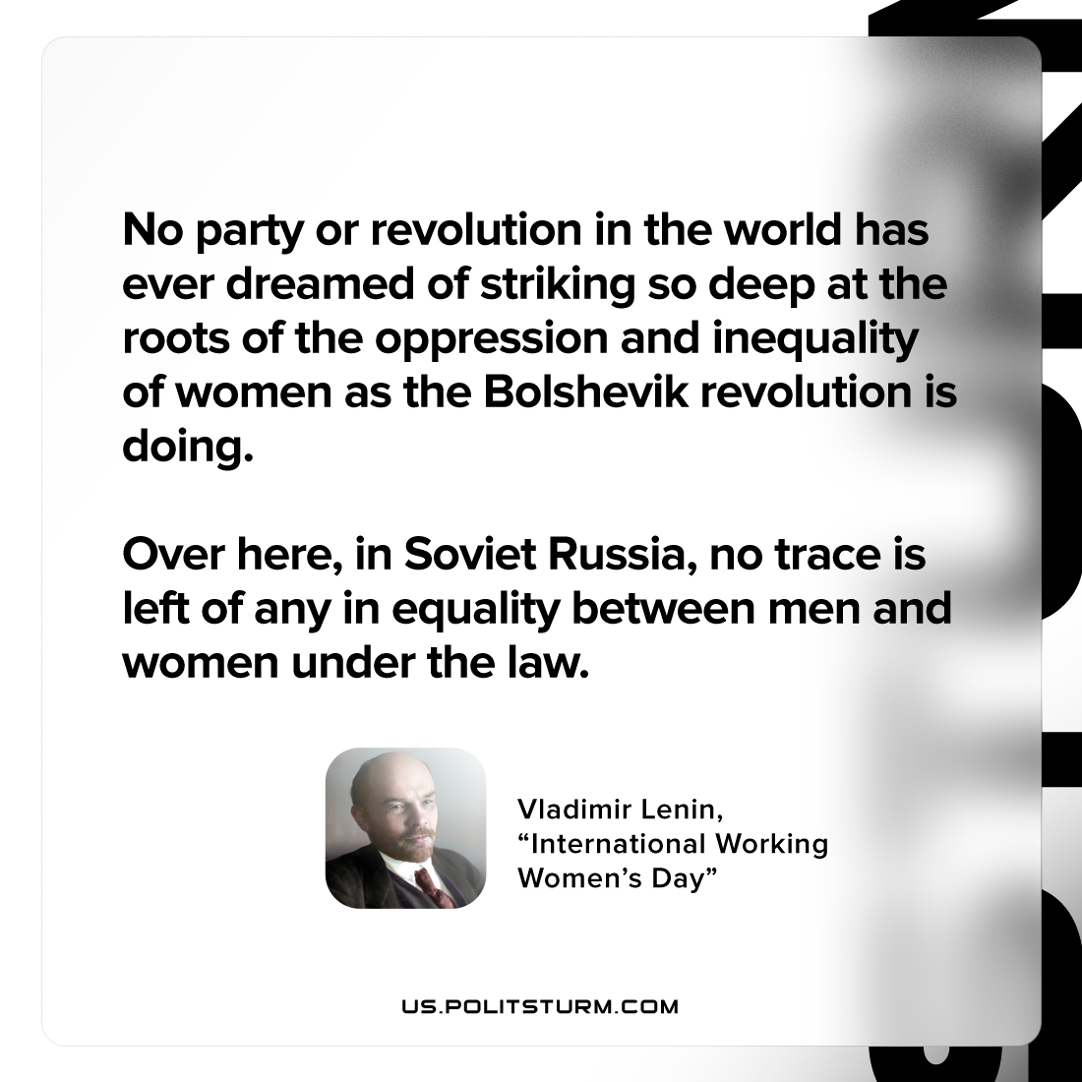

Original article
2023-05-04

"No party or revolution in the world has ever dreamed of striking so deep at the roots of the oppression and inequality of women as the Bolshevik revolution is doing. Over here, in Soviet Russia, no trace is left of any inequality between men and women under the law."
Vladimir Lenin, "International Working Women’s Day"

Original article

