Lenin on Being an Internationalist
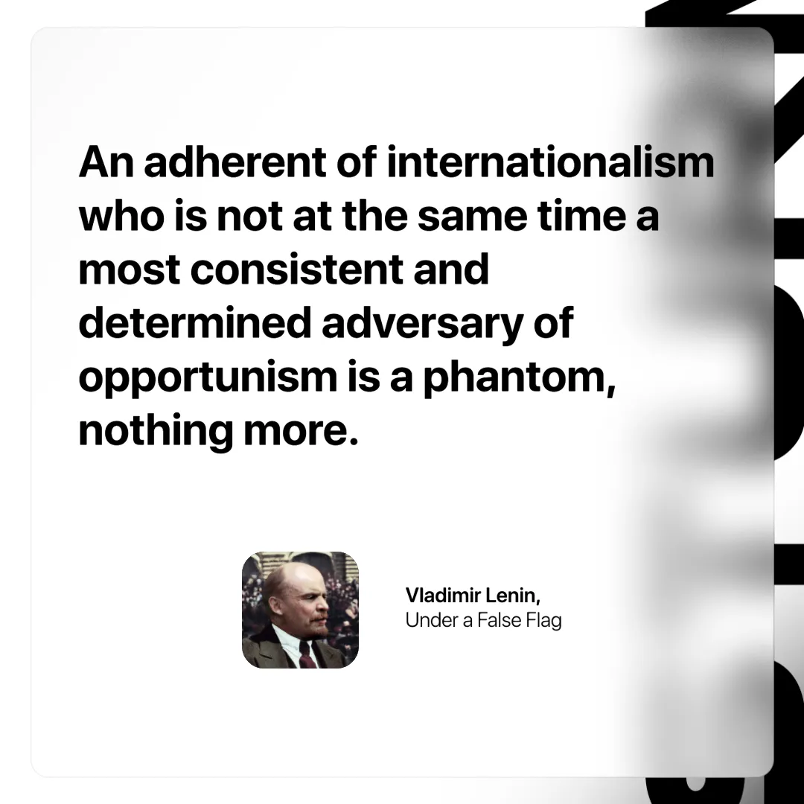

Original article
2025-03-30

"An adherent of internationalism who is not at the same time a most consistent and determined adversary of opportunism is a phantom, nothing more."
Vladimir Lenin, Under a False Flag

Original article

