Lenin on Attitude Towards Theory of Marxism
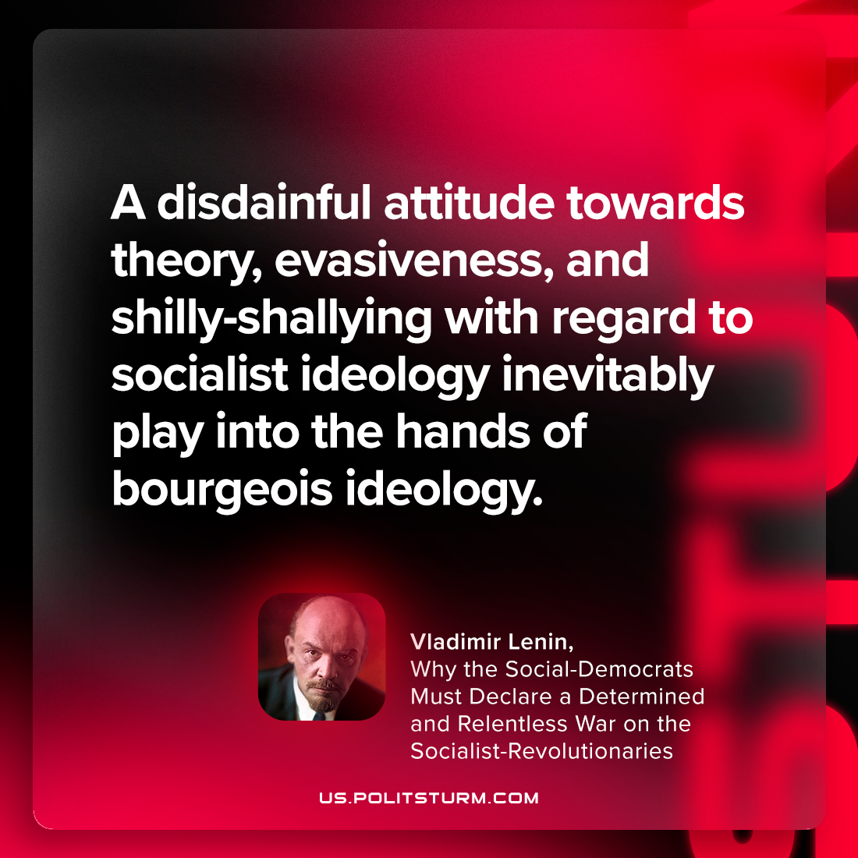

Original article
2023-04-18

"A disdainful attitude towards theory, evasiveness, and shilly-shallying with regard to socialist ideology inevitably play into the hands of bourgeois ideology."
Vladimir Lenin, “Why the Social-Democrats Must Declare a Determined and Relentless War on the Socialist-Revolutionaries”

Original article

