Lenin on Army and Police
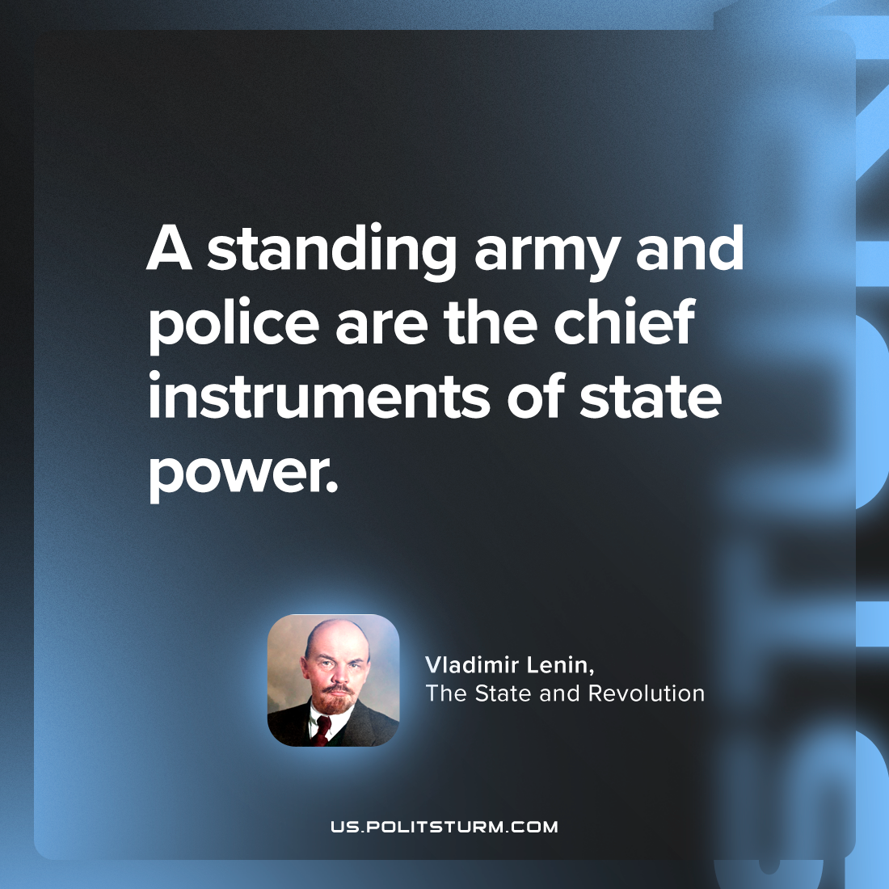

Original article
2024-01-09

"A standing army and police are the chief instruments of state power."
Vladimir Lenin, The State and Revolution

Original article

