Lenin on Amateurism in the Movement
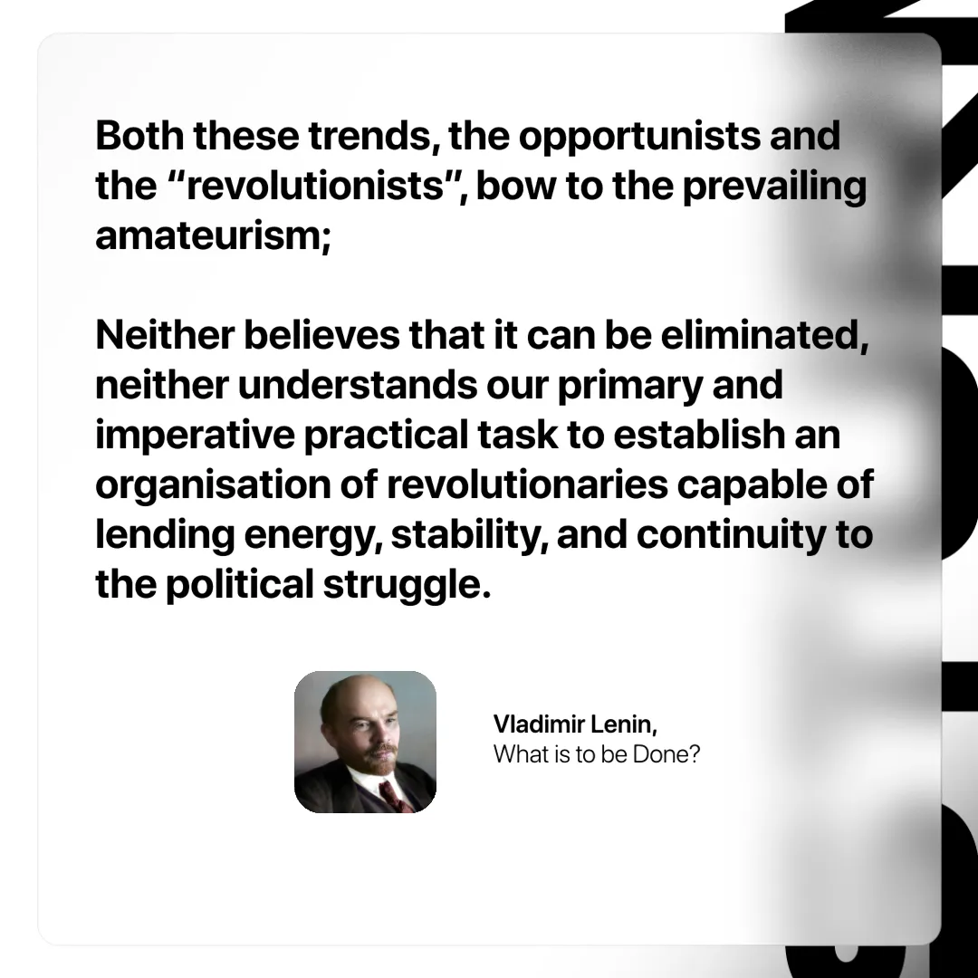

Original article
2025-01-26

“Both these trends, the opportunists and the “revolutionists”, bow to the prevailing amateurism; neither believes that it can be eliminated, neither understands our primary and imperative practical task to establish an organisation of revolutionaries capable of lending energy, stability, and continuity to the political struggle.”
Vladimir Lenin, What is to be Done?

Original article

