Lenin on Alternative to Imperialist Wars
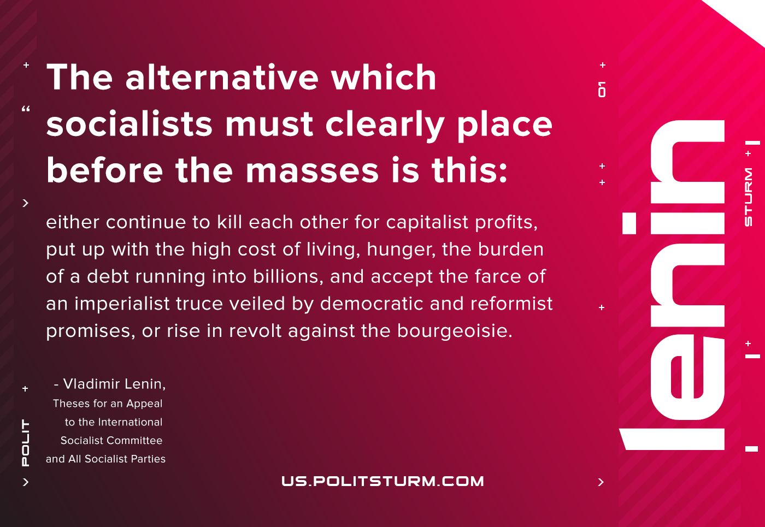

Original article
2021-01-14

The alternative which socialists must clearly place before the masses is this: either continue to kill each other for capitalist profits, put up with the high cost of living, hunger, the burden of a debt running into billions, and accept the farce of an imperialist truce veiled by democratic and reformist promises, or rise in revolt against the bourgeoisie.
Vladimir Lenin, “Theses for an Appeal to the International Socialist Committee and All Socialist Parties”

Original article

