Lenin on Alliances as 'Truces' Between Wars
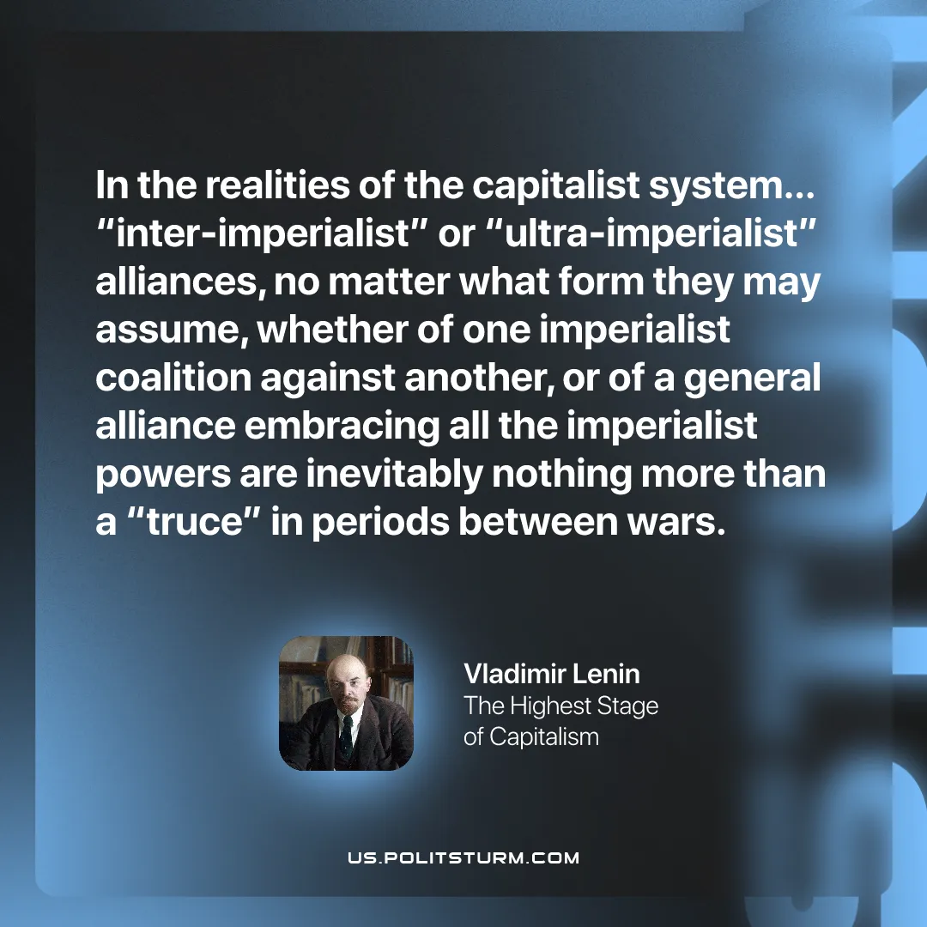

Original article
2026-03-05

“in the realities of the capitalist system… “inter-imperialist”or “ultra-imperialist” alliances, no matter what form they may assume, whether of one imperialist coalition against another, or of a general alliance embracing all the imperialist powers are inevitably nothing more than a “truce” in periods between wars.”
Vladimir Lenin, Imperialism: The Highest Stage of Capitalism

Original article

