Lenin on Achieving Socialism
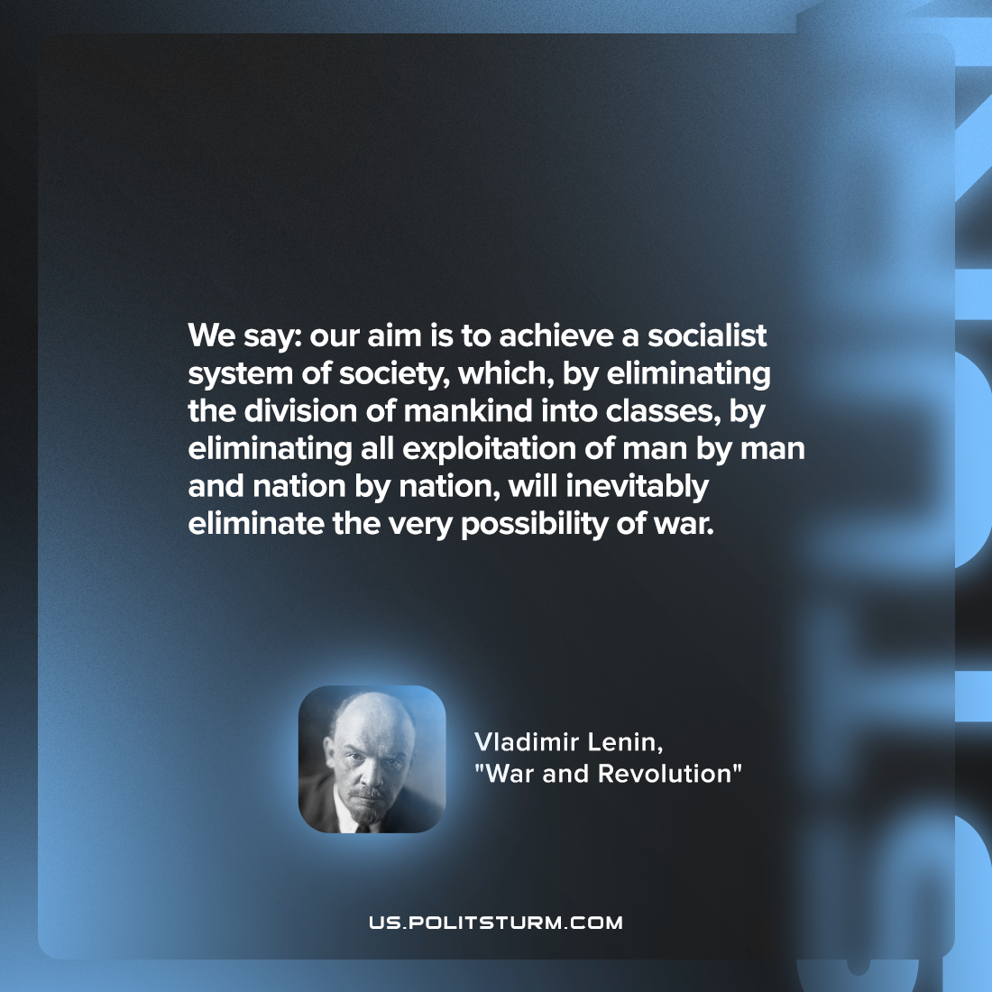

Original article
2022-06-01

We say: our aim is to achieve a socialist system of society, which, by eliminating the division of mankind into classes, by eliminating all exploitation of man by man and nation by nation, will inevitably eliminate the very possibility of war.

Vladimir Lenin, “War and Revolution”

Original article

