Lenin on Abolition of Classes
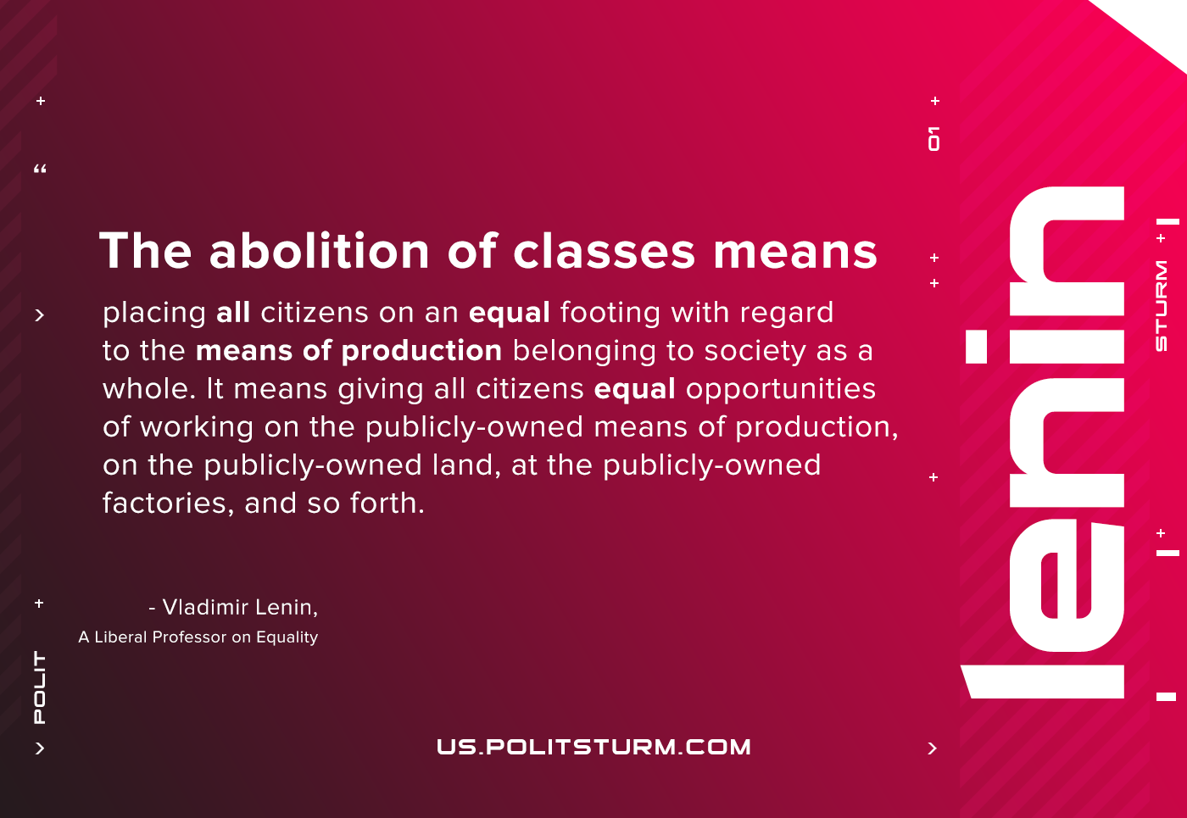

Original article
2021-05-20

The abolition of classes means placing all citizens on an equal footing with regard to the means of production belonging to society as a whole. It means giving all citizens equal opportunities of working on the publicly-owned means of production, on the publicly-owned land, at the publicly-owned factories, and so forth.
Lenin, A Liberal Professor on Equality

Original article

