Lenin on a Lack of Materialist Analysis Leading to Political Opportunism
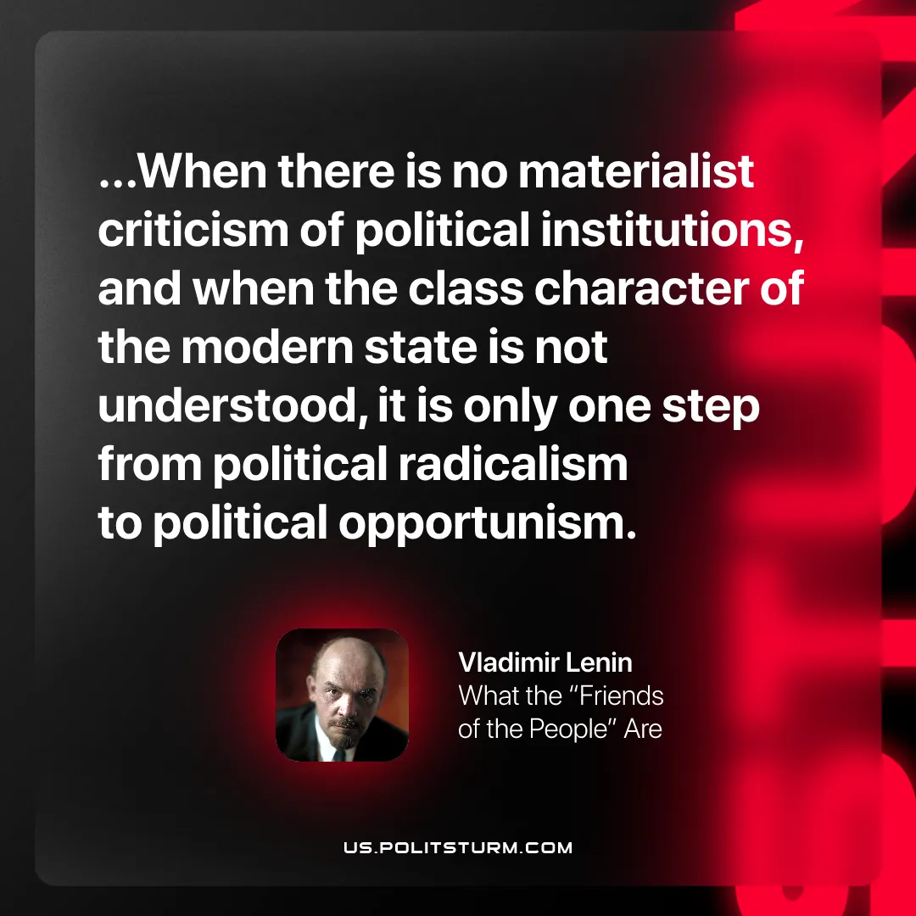

Original article
2026-01-29

“...When there is no materialist criticism of political institutions, and when the class character of the modern state is not understood, it is only one step from political radicalism to political
opportunism.”
Vladimir Lenin, What the “Friends of the People” Are

Original article

