Lenin on the Development of Opportunism
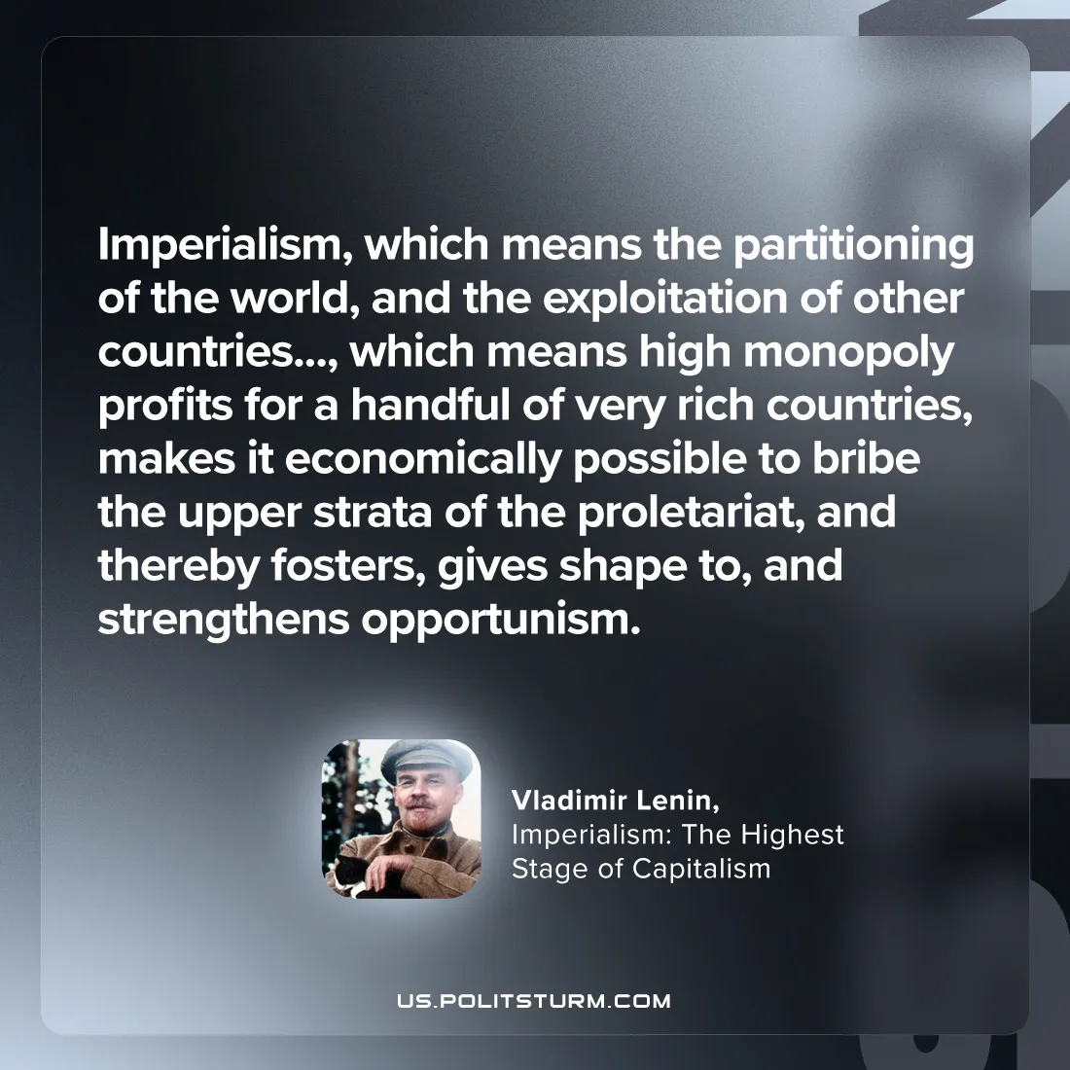

Original article
2024-08-24

"Imperialism, which means the partitioning of the world, and the exploitation of other countries…, which means high monopoly profits for a handful of very rich countries, makes it economically possible to bribe the upper strata of the proletariat, and thereby fosters, gives shape to, and strengthens opportunism.”
Vladimir Lenin, Imperialism: The Highest Stage of Capitalism

Original article

